Weed Management Plan

for

The Cosumnes River Preserve

Galt, California

2001 - 2005

Wildland Invasive Species Program
The Cosumnes River Preserve

The Nature Conservancy
Updated 9/2001 by Barry Meyers-Rice & Mandy Tu

Table of Contents

TABLE OF CONTENTS 2

1. INTRODUCTION 3
A. Cosumnes River Preserve Description and Management Goals 3
B. How Weeds Interfere With Management Goals 5

2. OVERVIEW OF WEED MANAGEMENT PLAN 6
A. Management Philosophy and Setting Priorities: An Adaptive Management Approach 6
B. Summary of Specific Actions Planned for the Cosumnes River Preserve 6
C. Management Tables 7

3. SPECIFIC WEED CONTROL PLANS 8
Anticipated woody invaders 8
Riparian invasive tree species 9
Arundo donax (giant reed or arundo) 10
Centaurea calcitrapa (purple starthistle) 11
Centaurea solstitialis (yellow starthistle) 12
Eichhornia crassipes (water hyacinth) 13
Foeniculum vulgare (fennel) 14
Lepidium latifolium (perennial peppergrass) 15
Rubus armeniacus (Himalaya blackberry) 16

APPENDICES 17
1. Emergency Information/Map to Hospitals 17
2. Blank Maps/Sample Maps 19
3. Herbicide Use Record Forms 19
4. Herbicide Labels 19

1. Introduction

A. Cosumnes River Preserve Description and Management Goals

The Cosumnes River is the only large waterway draining into California’s Central Valley that is not dammed. Its watershed spans 3,276 km² (1,265 mi²), and descends from an elevation of 2,316 m (7,600 ft) in the Sierra Nevada down to sea level. Restricted by only a small system of levees, the Cosumnes River floods seasonally. This flooding is essential for maintaining the riparian forests and freshwater marsh communities that have become degraded or completely lost elsewhere in California. These remaining natural communities lie along the Pacific Flyway and are important stopovers for many migratory birds, including greater and lesser sandhill cranes, tundra swans, northern pintails, and Canada geese.
The Cosumnes River Preserve was established in 1987 to protect valuable habitat in the lower reaches of the Cosumnes watershed. The preserve is part of the larger Cosumnes River project area that includes much of the watershed from the headwaters to the delta area. The long-term goal of the Project is to encompass a large and naturally functioning example of the Central Valley and foothill ecosystem with the full spectrum of the region’s natural communities. It is located along the eastern edge of the Sacramento-San Joaquin Delta near the confluence of the Cosumnes and Mokelumne Rivers (Figures 1a & 1b), and the total area of protected land (owned by TNC and other partners) numbers approximately 16,000 ha (40,000 acres). Four natural communities occur on the preserve: seasonal and permanent wetlands, riparian communities, valley oak savannas, and grassland-vernal pool mosaics. Portions of the preserve remain in use as cropland and for grazing. Six partners own the land parcels that constitute the preserve: The Nature Conservancy, Ducks Unlimited, US Bureau of Land Management, California Department of Fish and Game, Sacramento County Department of Parks and Recreation, and California Wildlife Conservation Board.

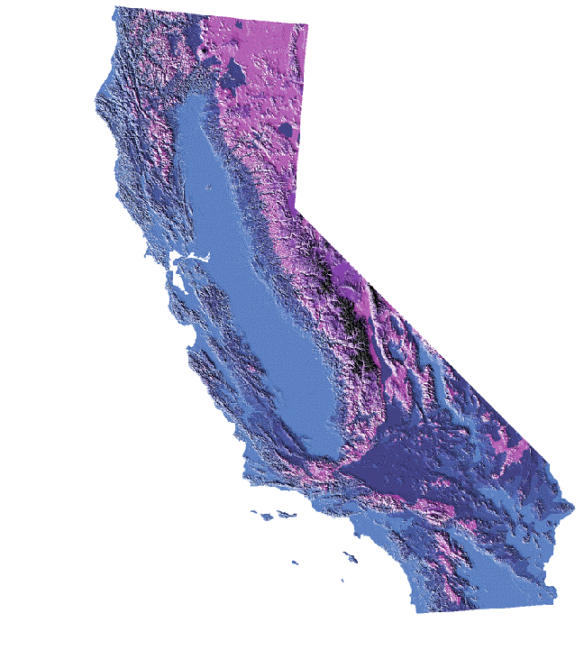
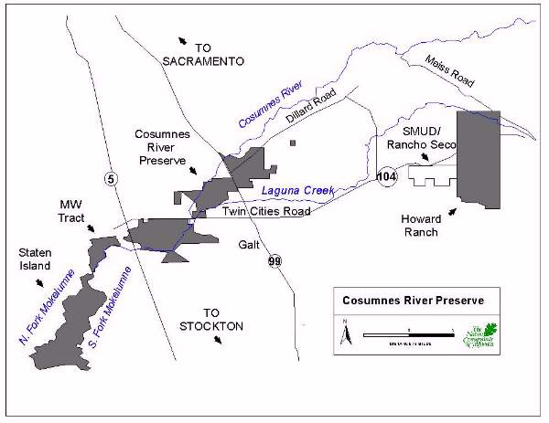

Figures 1a & 1b: The Cosumnes River Preserve

This weed management plan has been written for the Cosumnes River Preserve 2001 boundaries that exist between I-5 and Highway 99, including the Castello and Valensin properties, but excluding Howard Ranch, Staten Island, and MW Tract (Figure 2). This part of the preserve has a major role in reaching two of the overall project’s primary goals:
- Preserving and restoring remnant Central Valley riparian forest communities and aquatic systems throughout the full length of the Cosumnes River, from the Sierran headwaters to the Central Valley floodplain. This includes: preserving the entire riparian community with a focus on plant species composition; creating riparian forest corridors by connecting existing patches of riparian forests; preserving and restoring natural river and tidal slough hydrology; and alleviating bank instability problems.
Special attention is being given to enhancing populations of rare species which occur or occurred historically in this community, including Swainson’s hawk, ferruginous hawk, yellow-billed cuckoo, willow flycatcher, bank swallow, yellow-breasted chat, least Bell’s vireo, giant garter snake (Thamnophis gigas), chinook salmon (Onchorhynchus tshawytscha), valley elderberry longhorn beetle (Desmocerus californicus ssp. dimorphus), and California hibiscus (Hibiscus lasiocarpus).

- Preserving and restoring the permanent and seasonal wetlands (including vernal pools) that support resident and migratory waterfowl, fish, amphibians, and other invertebrates. The focus is on restoring the ability of the plant communities to provide food and shelter for these animals rather than on plant community composition. Special attention is being given to populations of greater and lesser sandhill cranes (Grus canadensis), northern pintail ducks (Anas acuta), and native fish (such as the Sacramento split-tail).
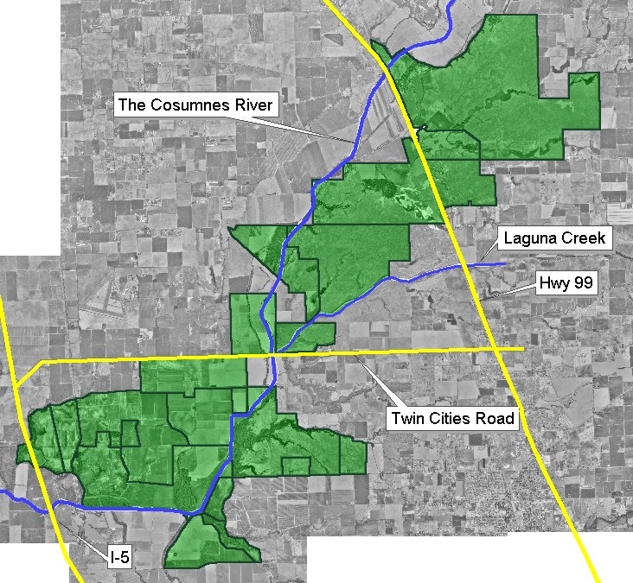

Figure 2: Cosumnes River Preserve

Three secondary management goals have been identified:
- Conserving the preserve’s grasslands and valley oak savannas while maintaining economically viable and ecologically compatible land uses. The focus is on maintaining waterfowl nesting habitat and quality rangeland and on preserving populations of valley oaks, native bunchgrasses and native forbs.
- Helping develop compatible economic uses of land on portions of the preserve as a model for neighboring private lands. This includes encouraging agricultural techniques that reduce pesticide use and sediment runoff, and provide food and habitat for wildlife.
- Serving as a public education resource and providing people opportunities to experience and further understand the region's diverse landscapes and biology. This is done by providing trails, a boardwalk, an interpretive center, tours and other activities.

B. How Weeds Interfere With Management Goals

The effects of the most troublesome weeds in the primary natural communities at the Cosumnes River Preserve are described below. Weed species found on roads and trails are also described. Sample weed survey maps are found in Appendix 2.

Riparian Forests
Riparian forest weeds include edible fig (Ficus carica), black locust (Robinia pseudoacacia), tree of heaven (Ailanthus altissima), Osage orange (Maclura pomifera), and honeylocust (Gleditsia triacanthos). These five tree species could alter community composition and structure if allowed to spread—in time they could dominate the canopy layer and even form monospecific stands as they have done or shown the potential to do in other Central Valley riparian forests. These changes would translate to a significant decrease in habitat quality. Populations of the fig, black locust, tree of heaven, and Osage orange are still on the preserve, and honeylocust, thus far, only occurs as small, isolated populations. Wych elm (Ulmus glabra) is another tree species that has been found only as small isolated individuals on the Preserve, has the potential to invade forested areas, and should be monitored for spread.
Woody species not yet on the preserve, yet found nearby, can pose new threats to the integrity of the forest community, and could decrease habitat quality for the conservation targets. Such weeds include Chinese tallow tree (Sapium sebiferum) and Chinese wisteria (Sesbania punicea).
The most important weeds that may modify both forested and non-forested riparian communities are Himalayan blackberries (Rubus armeniacus), perennial peppergrass (Lepidium latifolium), and fennel (Foeniculum vulgare). The effects of these species on riparian areas are not clear. The non-native Himalayan blackberry may outcompete and/or hybridize with the native California blackberry (Rubus ursinus). Meanwhile they might benefit some species of wildlife by providing additional food and shelter. (Together the blackberry species may reduce the recruitment of other riparian plants.) Perennial peppergrass infests and sometimes dominates former riparian forest sites, but it is uncertain whether it effects native tree recruitment. Fennel is common along roadsides on the preserve. While not a problem along the roadsides, it appears to prevent recruitment of valued plants when it grows in riparian communities. High profile infestations occur near the Visitor Center and on the Willow Slough Trail.
Arundo (Arundo donax) is not present on the preserve, but could spread from a nearby infestation on the Mokelumne River levee by the Franklin Boulevard bridge. Arundo is an aggressive invader that is a severe pest in other Californian riparian areas where it competes with native riparian species, promotes wildfire, and alters stream morphology and flow. Arundo does not provide food or nesting habitat for native animals.

Wetlands and Open Water
Water hyacinth (Eichhornia crassipes) and perennial peppergrass interfere with the primary management goals for wetland areas. Water hyacinth reduces sunlight and alters water chemistry, negatively affecting native aquatic plants and animals when it dominates tidal sloughs. The impacts of perennial peppergrass on wetland management goals are unclear. If it dominates seasonally-flooded wetlands, it may displace native marsh vegetation that produces more abundant food for waterfowl.

Grasslands and Savannas
Grasslands and savannas suffer the greatest concentrations of non-native species. Common in these areas are yellow starthistle (Centaurea solstitialis), medusahead (Taeniatherum caput-medusae), mustards (Brassica spp.), filarees (Erodium spp.), ripgut brome (Bromus diandrus), soft chess (Bromus hordeaceus), wild oats (Avena spp.), ryegrasses (Lolium spp.), Mediterranean barleys (Hordeum spp.), non-native fescues (Festuca spp.), and bur-clover (Medicago polymorpha). A few of these species are particularly problematic. Yellow starthistle is of special concern because it degrades waterfowl nesting habitat in grasslands and savannas. Purple starthistle (Centaurea calcitrapa) was recently found on the Preserve, but only in small isolated patches. It bears floral spines even longer than those of yellow starthistle, and if it were to invade widely, it could present a threat similar to yellow starthistle.

Trails, Roads
Weeds that interfere with road and trail uses include yellow starthistle and Himalayan blackberry. Yellow starthistle, with its spiny flowerheads, can be an obstruction and annoyance on dirt roads and trails, and may also become a fire hazard once the annual stems die. Yellow starthistle and fennel colonize adjacent grasslands and waterfowl nesting habitat from trails and levees. Himalayan blackberry obstructs movement along trails.

2. Overview of Weed Management Plan

A. Management Philosophy and Setting Priorities: An Adaptive Management Approach
Some weeds may be tenacious and harmful while others may restrict themselves to recently disturbed locations. Attempting to control all the non-native species present can be overwhelming and ultimately unsuccessful, so we developed a strategy to ensure the most efficient use of resources. The strategy is built upon two principles. First, instead of managing against weeds, our philosophy is to manage for the target species and communities we desire. With this spirit, we identified weed species that threaten the survival of the desired conservation targets. Second, to minimize the total, long-term weed control workload we act to prevent new infestations and contain the spread of plants with expanding ranges. Therefore we identified those infestations that are the fastest growing, most disruptive, and affect the most highly valued area(s) of the site.
Then we set priorities for each species’ control or elimination. These priorities reflected each weed’s present or future harmful impacts. Control methods were determined by consulting with TNC’s Wildland Invasive Species Program (WISP), preserve stewards, weed extension agents, and other experts. If leaving the weed unchecked would result in more damage than may be caused by controlling them, we developed appropriate control protocols. We also avoided control treatments during the summer months in areas where native or migratory nesting birds could be harmed. We gave higher priority to infestations we thought most likely to be controlled with available technology and resources.
We also noted species which are not yet on the preserve, but are found nearby and could be problems if they spread to the preserve. Our weed management program includes regularly monitoring the preserve for these species in order to quickly detect and eliminate them if they ever do appear.
In summary, we adopted an adaptive management strategy. An adaptive strategy is one that uses the lessons from previous seasons of work to mold future efforts. The various phases of our strategy are:
- We establish management goals for the site.
- The weeds interfering with these goals are identified and assigned priorities based on their impacts.
- We determine effective control options. We assess the likely effects on the target (and non-target) species, and if necessary adjust the weed priorities.
- We develop and implement the management plan.
- We monitor and assess the impacts of our management actions.
- We evaluate the effectiveness of our methods (measured against the site goals) and use this information to refine our control priorities, methods, and goals. We learn what is practical, effective, and realistic.
Return to step one...

B. Summary of Specific Actions Planned for the Cosumnes River Preserve
Control and monitoring programs planned for different habitats on the preserve are outlined below. Priorities for monitoring and controlling pest plant species are given in Table 1 (see “CRP-Tabl.xls” for Tables 1-5). High priority was given to plants that interfere with the most important management goals and whose populations are small and easiest to control now, before they spread. All listed species should be monitored at least every three years and mapped, if possible. Schedules for weed control are given in Table 2. Cost estimates for weed management are tabulated in Table 3.

Riparian Areas
We assigned high priority to eradicating fig, black locust, Osage orange, honeylocust, and tree of heaven from the preserve. We assigned high priority to monitoring for newly invading woody species. Chinese tallow tree (Sapium sebiferum) and Chinese wisteria (Sesbania punicea) have been seen along the Sacramento River, and would be serious problems on the preserve.
We assigned medium priority to prevent arundo from invading. We assigned medium priority to controlling fennel, low priority to monitoring blackberries, and medium priority to monitoring perennial peppergrass for indications it is expanding its range from wetlands into forested areas.
We will pull, cut, girdle, and/or apply herbicides to all individuals of the five high-priority tree species. All girdled or frilled trees will be left standing, except when the snags become a safety issue to humans. By leaving the dead trees standing, we reduce impacts to the surrounding vegetation, as well as create habitat for species that feed or nest in snags. To prevent arundo from invading we will work with neighbors to remove it from the Franklin Boulevard bridge site. We will control fennel infestations by the Visitor Center, along the Willow Slough Trail, and in Lost Slough, Willow Slough and other riparian areas. It does not interfere with management goals when present along the major roads through the preserve, and we believe the costs of controlling it there would outweigh the benefits of reducing the chances of re-introduction from these locations.
We are uncertain whether we should control blackberries. A rigorous study of this issue would be helpful, but is difficult for three reasons: 1) both native and exotic species are present; 2) identifications of the species are sometimes difficult, in part because they apparently hybridize; 3) the plants, even the non-natives, provide benefits such as cover and forage for native (especially bird) species. Simple investigations conducted by staff and volunteers could help determine if the various blackberry populations are spreading, and their impacts on the recruitment of valued riparian species.

Wetlands
We assigned medium priority to controlling water hyacinth and to containing and monitoring perennial peppergrass populations. Water hyacinth will be controlled by hand-removal and herbicide applications. Treatments will be carried out in cooperation with the Sacramento-San Joaquin Delta Boats and Waterways Program. We will begin containment efforts and continually monitor perennial peppergrass to determine if it is spreading in the wetlands and forest edges.

Grasslands and Savannas
We do not know how to control the many invasive species in the grasslands or restore native grassland at a reasonable cost. Control programs for these areas will, therefore, be limited to adapting land use practices that maintain or improve the waterfowl nesting habitat and which favor native species over non-natives.
We assigned high priority to preventing purple starthistle from invading. We will search for and remove purple starthistle annually. We assigned low priority to monitoring yellow starthistle. We will monitor it in waterfowl nesting habitat and in grazing areas to learn more about its range on the preserve and if it can be controlled. We will control yellow starthistle around the Visitor Center and trailheads—see below—but not elsewhere; it is extremely widespread throughout the region.

Trails, Roads
We assigned high priority to controlling yellow starthistle along trails, dirt roads and around the Visitor Center. Yellow starthistle uses areas of such high disturbance as pathways to colonize new habitats. We assigned low priority to controlling blackberries along trails or dirt roads.
We will control yellow starthistle along all roads and trails adjacent to significant nesting habitat, along the Willow Slough Trail, all drivable levees, and around water control structures. Treatments may include cutting, grazing, prescribed burning or flame torching, and/or herbicide applications. We will prune blackberries along the Willow Slough Trail.

Other Species to Watch For
Smooth-leaved elm (Ulmus minor) appears to be spreading vegetatively near the farmhouse at the corner of Desmond and Bruceville Roads. It is not a problem at this time, but we will check to make sure it is not spreading beyond this patch. Poison hemlock (Conium maculatum) is toxic to humans. We may remove specimens from around the visitor center and produce a warning brochure on the species. Isolated seedlings and saplings of Wych elm (Ulmus glabra) have recently been found on the Preserve, and should also be monitored for spread. If it is spreading, it should be given high priority for eradication.

Inventory, Monitoring, Education
We are educating the preserve’s volunteers (e.g. Habitat Restoration Team, Point Reyes Bird Observatory, etc.) to map and otherwise note weed populations as they conduct other work. This will serve both to monitor known weed populations and act as an early warning system for new invasions by honeylocust, pampas grass, arundo, purple starthistle, or other species.
It is important to know the distributions of the weed species on the preserve. It will allow us to monitor the spread of each species and the efficacy of the weed control tactics we use. Blank survey maps have been included. These should be photocopied and the distribution of each weed should be mapped. Sample maps for yellow starthistle and perennial peppergrass from 1996 are included as examples.
Using the survey maps generated by the staff and volunteers, the effectiveness of previous years’ control measures will be examined and refined each January. This meeting will be used to plan the weed control measures to be implemented over the next year.

C. Management Tables
The tables in the Excel spreadsheet “CRP-Tabl.xls” outline how we will implement our weed management plan. Table 1 lists the weed species and their priority for control efforts. Table 2 contains the schedule of implementation for weed control. Note that prior to each growing season, the upcoming year’s control efforts must be scheduled (in winter) while taking into account results from the previous year. Table 3 estimates the costs in money and time that will be incurred to carry out the plan for the next 4 years. Table 4 is an accounting sheet that records the actual costs for the weed management program. Each species will have its own itemized account for resource costs each year. Table 5 allows us to calculate the differences between the projected (Table 3) and actual (Table 4) resource costs per year for use in future management planning.

3. Specific Weed Control Plans

Anticipated woody invaders (species not yet on the site but found nearby)

Priority: High (in all areas)—Sapium sebiferum (Chinese tallowtree), and Sesbania punicea (Chinese wisteria), and can infest riparian areas and interfere with primary management goals. Identifying and eradicating new infestations before they become entrenched is the most cost-effective weed management strategy, and so we give this strategy high priority in all areas of the preserve.
Description
These plants are escaped horticultural woody species. Sapium sebiferum is a tree similar in form to a poplar, and which bears white, popcorn-like fruit. Unlike poplars, it has white milky sap (it is in the euphorbia family). Sesbania punicea is a small leguminous tree with woody seedpods and bright, reddish pea-like flowers.
Current Distribution on the Preserve
Sapium sebiferum and Sesbania punicea have not yet been observed on the preserve, but would be serious problems if the became established.
Measurable Objectives and Goal
Goal: Detect any established plants and eradicate
(1) Continue yearly surveillance for new invasions of Sapium sebiferum and Sesbania punicea
Control Options
Control options may be used only with the permission of the appropriate landowner and compliance with applicable environmental regulations. The Cosumnes Preserve Manager is responsible for meeting these requirements and approving any trained staff or certified pesticide applicators who will handle herbicides. He/she should be consulted before actions are taken. Staff in charge are responsible for assuring that all participants are trained in the proper handling of tools and materials.

(1) Hand-pull all seedlings, or use a weed wrench to remove saplings.
(2) If mature trees are found, cut them and treat the stumps with an herbicide. Frilling may also be used.
Treatment Schedule
April–May: Locate and remove all seedlings of these woody species in the Preserve’s riparian areas. Record location with GPS.

Fall: Treat mature trees. Record location with GPS. Revisit prior locations to ensure successful eradication has been achieved.
Cost Estimates
Monitoring these species will require monitoring and removal (1 staff x 8 hrs; 10 volunteers x 6 hrs), and resprout control (1 staff, 8 hrs). Costs are low because this can be done at the same time as similar work for other tree weeds.
Annual costs are estimated at $30- fuel and $15- refreshments for volunteers.

Riparian invasive tree species

Priority: High (in riparian areas)—Ailanthus altissima (tree of heaven), Ficus carica (edible fig), Gleditsia triacanthos (honeylocust), Maclura pomifera (Osage orange), Robinia pseudoacacia (black locust), Ulmus minor (smooth-leaved elm), Ulmus glabra (Wych elm), and Morus alba (white mulberry),can infest riparian areas and interfere with primary management goals. The populations of these trees are still small and it is still possible to extirpate them.
Description
These plants are escaped horticultural woody species that thrive in the wet forested areas of Cosumnes River Preserve.
Current Distribution on the Preserve
Complete surveys have not been completed, but the following populations are known: Ailanthus altissima—Valensin, Willow Slough and the railroad tracks; Ficus carica—at least four stands in the Tall Forest; Gleditsia triacanthos—Valensin and Tall Forest; Maclura pomifera—Valensin and Tall Forest; Robinia pseudoacacia—Valensin and near the barn and farmhouse; Ulmus glabra—young plants have been found in Valensin; Morus alba—one mature tree has been found in Valensin. Ulmus minor appears to be spreading vegetatively near the farmhouse at the corner of Desmond and Bruceville Roads. This is not in a riparian area, but it may act as a seed source.
Measurable Objectives and Goals
Goal: Eradicate
(1) Locate and map all specimens on the preserve.
(2) Eradicate existing plants within three years
(3) Continue yearly surveillance. Consider restoration at areas of dense infestations if they do not recover within three years.

These species may resprout following cutting, or girdling, especially if they are not treated with herbicides. To minimize this, trees will be treated with herbicides, preferably triclopyr or glyphosate plus dye. Cut stump or hack & squirt treatments may be used against any size tree. Basal bark treatments are effective only on young, thin-barked trees. Foliar spray treatments can be used against small trees, but this method has the highest potential for herbicide drift and resultant injury to non-target vegetation.
Control Options
Control options may be used only with the permission of the appropriate landowner and compliance with applicable environmental regulations. The Cosumnes Preserve Manager is responsible for meeting these requirements and approving any trained staff or certified pesticide applicators who will handle herbicides. He/she should be consulted before actions are taken. Staff in charge are responsible for assuring that all participants are trained in the proper handling of tools and materials.

(1) Hand-pull or weed wrench all seedlings and saplings.
(2) Cut any mature trees and treat the stumps with an herbicide. Frilling, in conjunction with herbicides, may also be preferred for Ailanthus and Robinia because these species resprout vigorously when cut. Glyphosate or triclopyr are effective.
Treatment Schedule
April–May: Locate and remove all seedlings of these woody species in the Preserve’s riparian areas. Create survey maps using blanks copied from the Appendix. Record locations with a GPS unit if possible.

Summer-Fall: Treat mature trees. Avoid treatment during summer months in areas where nesting birds occur. Leave snags if they provide useful nesting habitat, and do not endanger personnel. Treat Ficus carica one month before leaf drop for maximum effectiveness. Foliage of Maclura pomifera is bright yellow in the fall, and additional plants could be detected this way.
Cost Estimates
Controlling invasive trees will require an estimated 232 hours of staff time and 900 hours of volunteer labor for the first year. This includes estimates for initial monitoring (1 staff x 8 hrs x 5 d, 10 volunteers x 6 hrs x 3 d), control work (2 staff x 8 hrs x 8 d, 10 volunteers x 6 hrs x 8 days), and follow-up control/monitoring (2 staff x 8 hrs x 4 d, 10 volunteers x 6 hrs x 4 d). These estimates will drop by 30% in each successive year.
Yearly costs for materials are estimated as follows: herbicide- $275 the first year (reduced by $80/year); protective gear- $238/year (35 tyvek suits - $210, gloves - $28); fuel - $210/year, and refreshments for volunteers- $420 (reduced by $120/year). The costs of restoration work have not been estimated.

Arundo donax (Giant Reed or Arundo)
Priority: Medium (in riparian areas)—arundo can infest riparian areas and interfere with primary management goals. The Franklin Boulevard population adjacent to the preserve should be removed before it spreads to the preserve.
Description
Arundo is a rhizomatous perennial cane-like grass with light green leaves that diverge from the stem in a distinctive herringbone pattern. It grows up to 8 m tall in riparian areas, seeps and ditchbanks.
Current Distribution on the Preserve
Riverbank on land adjacent to the preserve—the south side of the Mokelumne River by the Franklin Boulevard bridge.
Measurable Objectives and Goal
Goal: Prevent establishment on the preserve.
(1) Locate and remove all arundo on the preserve and continue surveillance for new invasions.
(2) Eradicate the patch on the south side of the Mokelumne River by the Franklin Boulevard bridge within two years.
(3) Influence the Department of Water Resources to prevent the spread of arundo when building new levees near the preserve.
Control Options
Control options may be used only with the permission of the appropriate landowner and compliance with applicable environmental regulations. The Cosumnes Preserve Manager is responsible for meeting these requirements and approving any trained staff or certified pesticide applicators who will handle herbicides. He/she should be consulted before actions are taken. Staff in charge are responsible for assuring that all participants are trained in the proper handling of tools and materials.

(1) Work with neighbors and the Department of Water Resources to eliminate the population or at least prevent its spread during the construction of the new Thornton levee by first cutting and safely removing or burning it, then applying herbicide to cut stems and later to resprouts.

The most effective herbicidal treatment of arundo is a foliar application of 2-5% solution of Rodeo, applied post-flowering but pre-dormancy. This is usually mid-August to early November.

Treatment Schedule
January: Develop a plan with the neighbors to cut, apply herbicide, and/or safely remove the Franklin Boulevard bridge infestation. Contact the Department of Water Resources to control any other arundo infestations prior to re-construction of the Thornton Road levee.
April–May: Locate any new infestations. Create a survey map using blanks copied from the Appendix.
August–November: treat arundo.
Cost Estimates
It will require approximately 4 hours for 1 staff member to meet with the property owner and the Department of Water Resources staff regarding control of arundo by the Franklin Blvd. bridge. Surveying the preserve for infestations is estimated to require 4 hours of staff time and 15 hours volunteer time (5 volunteers, 3 hours) annually. Annual costs are estimated at $10 for fuel and herbicide, and $15 for refreshments for volunteers.
Centaurea calcitrapa (Purple Starthistle)
Priority: High (in grassland areas)—Purple starthistle has only been found in a few small, isolated patches on land near the Preserve. If it establishes itself on the preserve it may rapidly spread into large infestations, and would then be very difficult to control. The threats posed by this species are likely to be similar to those of yellow starthistle.
Description
Annual or perennial herb in the sunflower/thistle family (Asteraceae). Young rosettes bear pinnately-lobed leaves up to 30 cm. long. It bolts in late spring producing purple flowers in dense heads surrounded by bracts with stout spines up to, and exceeding, 25 mm long.
Current Distribution on the Preserve
Purple starthistle has not yet been located on the preserve but it is distributed at nearby sites in the Central Valley, including the nearby Jepson Prairie Preserve.
Measurable Objectives and Goal
Goal: Detect purple starthistle as soon as it arrives on the preserve. Prevent it from being transplanted unintentionally to the preserve.
- Locate and remove any purple starthistle on the preserve twice every summer prior to seed production.
- Establish a protocol to clean equipment that is used in areas off the preserve that may be infested with purple starthistle.

Control Options
Control options may be used only with the permission of the appropriate landowner and compliance with applicable environmental regulations. The Cosumnes Preserve Manager is responsible for meeting these requirements and approving any trained staff or certified pesticide applicators who will handle herbicides. He/she should be consulted before actions are taken. Staff in charge are responsible for assuring that all participants are trained in the proper handling of tools and materials.

- Pull or dig out plants when infestations are first detected.
- Clean any fire equipment that may be used at Jepson Prairie, prior to its returning to the Cosumnes River Preserve.

Treatment Schedule
June: Survey for new infestations, and create a survey map using blanks copied from the Appendix. Use any of the management options to remove all purple starthistle prior to seed production both on the Preserve and, if possible, in areas adjacent to the preserve. All treated plants will be monitored and re-treated every four weeks until they are eliminated.
Cost Estimates
Monitoring and controlling purple starthistle will require an estimated 8 hours staff time and 6 hours volunteer time annually. Estimated annual costs include $20 for fuel and $15 for refreshments.

Centaurea solstitialis (Yellow Starthistle)
Priority: High (trails & Visitor Center), low (grassland areas)—High priority has been assigned to removing unsightly infestations around the Visitor Center and along trails, which it can use to invade new areas. It interferes with primary management goals in grasslands by diminishing waterfowl nesting habitat, but the infestation is too large to eradicate with available technology.
Description
Annual taprooted herbaceous plant in the sunflower/thistle family (Asteraceae). It can grow up to 1 m tall with distinctive gray-green leaves and stems and yellow flowerheads surrounded by spiny bracts. It produces abundant seed each year.
Current Distribution on the Preserve
Extensive populations throughout the preserve’s Savanna areas, along the trails, and near the visitor center. Other units containing populations of yellow starthistle are shown in the Appendix sample maps.
Measurable Objectives and Goal
Goal: The yellow starthistle infestation is extensive in and around the preserve, and cannot be eradicated with available technology. Instead, our objectives are:
- Eradicate the pest along all roads and trails that lead to uninfested areas.
- Reduce infestations along the Willow Slough trail, especially at the trailhead and near the visitor center.
- Determine the extent of the infestation on the preserve and the value of controlling it in grasslands and savannas, especially in areas where waterfowl nest.
Control Options
Control options may be used only with the permission of the appropriate landowner and compliance with applicable environmental regulations. The Cosumnes Preserve Manager is responsible for meeting these requirements and approving any trained staff or certified pesticide applicators who will handle herbicides. He/she should be consulted before actions are taken. Staff in charge are responsible for assuring that all participants are trained in the proper handling of tools and materials.

- Hand pull plants where infestations are small.
- Spot treat infestations with clopyralid with an added dye early in the growing period.
- Clean vehicles before entering uninfested areas.

The yellow starthistle infestation is extensive. Lesser-priority areas will have to be neglected. Highest priority will be given to reducing new outbreaks and to removing the plant from currently infested roads and trails that lead to uninfested areas.
One or more of the following methods may be used prior to seed production: early season herbicide application (clopyralid), repeated mowing/weed whacking, hand pulling. Cutting effectively reduces seed production if plants are cut when about 2% of the flower heads have opened, and then again 4-6 weeks later.
Treatment Schedule
June: Map and monitor infestations (see Monitoring, below) to act as an early warning system for new colonies as they develop, and to determine population trends.
June-July: Cut or apply herbicide when 2% of the flower heads have opened.
Cost Estimates
The costs and labor needs for controlling yellow starthistle in grassland areas have not yet been estimated. Controlling yellow starthistle by the Willow Slough trailhead and the Visitor Center will require an estimated 16 hours of staff time, 60 hours of volunteer time, and $45 annually. This includes estimates for mapping and pre- and post-treatment, refreshments for volunteers, some control efforts, and monitoring.

Eichhornia crassipes (Water Hyacinth)
Priority: Medium (in wetland areas)—Water hyacinth infests sloughs and other open-water wetland areas and interferes with primary management goals. Even if eliminated from the preserve, it would quickly reappear because it is widespread in the Sacramento-San-Joaquin Delta. It can, however, be controlled seasonally and kept from infesting more sloughs on the preserve.
Description
An aquatic plant with glossy, floating leaves up to 10 cm wide supported on bulbous petioles. Its showy, lilac-colored flowers are produced on a spike that sticks up above the leaves.
Current Distribution on the Preserve
Primarily in Lost Slough, particularly during the summer and fall.
Measurable Objectives and Goal
Goal: Reduce the water hyacinth in Lost Slough, and prevent its spread.
(1) Locate all water hyacinth on the preserve each summer and continue surveillance for new invasions in perpetuity.
(2) Reduce summer peak cover to a maximum of 10% absolute cover in any 500 meter slough section, every year.
(3) Prevent the plant from spreading to other preserve wetlands.
Control Options
Control options may be used only with the permission of the appropriate landowner and compliance with applicable environmental regulations. The Cosumnes Preserve Manager is responsible for meeting these requirements and approving any trained staff or certified pesticide applicators who will handle herbicides. He/she should be consulted before actions are taken. Staff in charge are responsible for assuring that all participants are trained in the proper handling of tools and materials.

(1) Use a boom to prevent the plants from floating into Lost Slough.
(3) Manually remove plants from Lost Slough.
(4) Coordinate with and guide the control actions of the State Boats and Waterways Program and associated agency staff.
(5) Apply acetic acid or herbicide/adjuvant certified for use over water to foliage.
(6) No treatment.
Treatment Schedule
June–September: Locate, treat, and remove all new water hyacinth infestations in preserve water channels monthly. Find and map water hyacinth on the preserve. Construct an experimental boom across Lost Slough to prevent new influxes of the weed from entering.
Treat water hyacinth in Lost Slough each summer in cooperation with the State Boats and Waterways Program and associated agency staff (e.g., Sacramento County Vector Control) who oversee control in the Sacramento-San Joaquin Delta. Inform agency staff they may not spray herbicides aerially on the preserve. Water hyacinth could be removed by a contractor using excavators, but it would cost at approximately $5000, and the likelihood of reinfestation makes this option unattractive. The simplest control would be via manual removal using work parties, combined with some herbicide or acetic acid use.

Cost Estimates
Water hyacinth would require an estimated 24 hours of staff time, 220 hours of volunteer time, and $140 annually. An initial annual workday (2 staff x 8 hrs, 20 volunteers x 8 hours, $100 for fuel and refreshments) would attack the main infestations along the slough waterways and by the booms. Additional monitoring would require 8 hours staff time and 60 hours volunteer time for monitoring annually, and $40 for refreshments.

Foeniculum vulgare (Fennel)
Priority: Medium (in riparian areas)—Fennel interferes with primary management goals in riparian communities and is considered a visual blight around the Visitor Center and on the Willow Slough Trail. It forms monospecific patches that likely prevent recruitment of riparian species. The relatively small, slowly expanding populations in important areas may be easily controlled with herbicides. Roadside populations are not a threat to management goals at this time.
Description
A perennial, anise-scented, taprooted herb up to 2 meters tall with very finely divided leaves. Flowers in mid-summer.
Current Distribution on the Preserve
Fennel occurs along the first leg of the Willow Slough Trail, in one large patch on the edge of the Willow Slough and Lost Slough riparian communities, by the Visitor Center, and along Franklin Boulevard and Interstate-5.
Measurable Objectives and Goal
Goal: Eradicate patches along the Willow Slough Trail, on the edge of Willow Slough and Lost Slough, and near the Visitor Center.
(1) Monitor for new infestations.
(2) Eradicate fennel infestations by the Visitor Center, along the Willow Slough Trail and other riparian areas within three years.
(3) If the post-eradication area does not have natural vegetation four years after fennel removal, consider restroation replantings.
(4) Within five years determine the need and ability to control non-riparian populations of fennel on the preserve.

Control Options
Control options may be used only with the permission of the appropriate landowner and compliance with applicable environmental regulations. The Cosumnes Preserve Manager is responsible for meeting these requirements and approving any trained staff or certified pesticide applicators who will handle herbicides. He/she should be consulted before actions are taken. Staff in charge are responsible for assuring that all participants are trained in the proper handling of tools and materials.

(1) Cut or burn fennel. Two to four months later, apply a wetland-certified herbicide/adjuvant with dye to all regrowth.
(2) Cut repeatedly.

The most successful method known is to treat with triclopyr or glyphosate in March–April when regrowth is 0.3–0.6 m tall. Both Garlon 3A (2% concentration with 0.5% non-ionic surfactant) and Garlon 4 (1.5% concentration) are effective. Concentrations as low as 1% Garlon 3A or 0.75% Garlon 4 may also be effective when applied thoroughly in spot treatments. Glyphosate was also reported to be effective when sprayed (2% Roundup) and brushed on (100% Roundup). It controlled plants under 0.3 m tall, plants that were cut and immediately treated, and regrowth sprayed 1–2 months after canes were cut. Where herbicides are used, signs should be posted warning visitors not to touch or eat the plants. It may be useful to cut or burn old canes during the late fall when they are dormant.
Mowing fennel yearly reportedly reduced infestations over time on property adjacent to the preserve. Flame treatments will require repeat applications. Combinations of techniques may also be effective.
Treatment Schedule
June–August: Locate and map all fennel infestations in riparian areas using blanks copied from the Appendix.
October–November: Cut plants by the Visitor Center, along Lost and Willow Sloughs and on the Willow Slough Trail.
March–April (Year #2): Treat resprouts from populations cut in October-November with triclopyr or glyphosate.
May, July, September (Year #2): Check treated areas every two months and re-treat all new sprouts until the plants are killed.
Cost Estimates
Controlling fennel will require an estimated 52 hours staff time and 174 hours volunteer labor in the first year, diminishing by 50% yearly from the preceding year for each of the next two years, then dropping to only the 8 hours staff time needed for mapping in the 4th and 5th years. First year work includes mapping (1 staff x 4 hrs), cutting by the Visitor Center and Willow Slough Trail, and in the Willow Slough and Lost Slough riparian communities (1 staff x 8 hrs; 10 volunteers x 6 hrs), post-cutting treatments (2 staff x 8 hrs; 10 volunteers x 6 hrs), and final follow-up monitoring and treatments (3 staff x 8 hrs; 9 volunteers x 6 hrs).
Annual estimated costs for the first three years include use of herbicide, and/or flame equipment and materials ($35 for each of the first three years), and refreshments for volunteers ($75 the first year, then reduced by half yearly). The costs will drop to 0 in the 4th and 5th years. The costs of restoration work have not been estimated.
Lepidium latifolium (Perennial Peppergrass)
Priority: Medium (in riparian areas and wetland areas)—Perennial peppergrass is scattered throughout riparian and seasonal wetland areas of the preserve and may interfere with primary management goals for these areas. In riparian areas, it is rare under forest canopy. It may also interfere with agriculture goals if it invades rice fields. We do not know whether populations are spreading or stable or how difficult it will be to control. Valley Oaks might have a higher survival rate when planted among perennial peppergrass then among annual grasses.
Description
A perennial rhizomatous herb in the mustard family that grows up to 2 m tall in dense stands. Tiny, four-petaled white flowers are produced in clusters near the ends of branches. Basal rosette leaves are up to 37 cm long and 8 cm wide, while stem leaves are only up to 10 cm long.
Current Distribution on the Preserve
The most extensive infestations occur along the Lost Slough Riparian Corridor and by the Visitor Center. A map of the weed’s distribution on the preserve is included in the Appendix. Areas east of the Cosumnes River have not been surveyed.
Measurable Objectives and Goal
Goal: Determine the threat posed by perennial peppergrass, and begin containment efforts.
(1) Locate and monitor perennial peppergrass infestations on the preserve and continue surveillance for new invasions.
(2) Determine if perennial peppergrass populations are changing (defined as an absolute cover change or range expansion of at least 30% in five years), if new colonies are forming, and the effect of perennial peppergrass on riparian trees.
(3) Begin control efforts by mowing test plots in early summer, to be followed by herbicide application in late summer. Expand this program if it is demonstrably successful.
Control Options
Control options may be used only with the permission of the appropriate landowner and compliance with applicable environmental regulations. The Cosumnes Preserve Manager is responsible for meeting these requirements and approving any trained staff or certified pesticide applicators who will handle herbicides. He/she should be consulted before actions are taken. Staff in charge are responsible for assuring that all participants are trained in the proper handling of tools and materials.

(1) Cut, pull, mow repeatedly, and/or use a weed whacker.
(2) Mow, then apply herbicide.
Treatment Schedule
June–August: Map perennial peppergrass every three years.

Summer: Mow infestations in early summer, and spray herbicide (Telar) in late summer.
Cost Estimates
Investigating population trends and control of perennial peppergrass will require an estimated 80 hours of staff time and 100 hours of volunteer time in the first year, dropping to 48 hours staff time and 100 hours of volunteer time in each of the subsequent years. This includes the first-year exploratory investigations of impacts on riparian trees (data collection: 1 staff, 60 hrs; 5 volunteers, 20 hrs; analysis: 1 staff, 20 hrs), and four years of continued monitoring, mapping, and containment of the weed.
Estimated annual costs include the mowing and containment of the weed, and considers maintenance and equipment costs ($1,500/yr for materials, fuel, protective gear, and/or herbicide), and the cost of refreshments for volunteers.

Rubus armeniacus (Himalayan Blackberry)
Priority: Low (in riparian areas)—Himalayan blackberry (also known as R. discolor and R. procerus) is vigorous and troublesome and can grow in riparian areas. It also has characteristics that may be beneficial to some species (particularly birds) and we are uncertain if it is a net asset or liability to our riparian areas. We are uncertain of the effects of these blackberries on native blackberries and other species. Native tree seedlings may be shaded out under Himalayan blackberry, especially in stands covered by the native wild grape. There may also be another non-native blackberry on the preserve, R. pensilvanicus (loganberry). R. armeniacus and R. pensilvanicus may hybridize with each other and with the native R. ursinus (Californian blackberry). More study is needed on blackberry (and its hybridization potential) before we can make further decisions on its control.
Description
Himalayan blackberries are prickly, bramble-forming perennial shrubs. They are common in disturbed moist areas and along roadsides and fencerows. Distinguishing among the Rubus species and hybrids at Cosumnes can be difficult.
Himalayan Blackberry: a) 5-angled stems 0.5–1.7 cm in diameter, often reddish, with wide, curved prickles, b) compound leaves comprised of 3-5 toothed leaflets that are generally widest above the middle and have white undersides, and c) oblong fruit.
Logan Blackberry: Similar to Rubus armeniacus (stout 5-angled stems with wide, curved prickles and leaves with 3-5 leaflets and toothed margins), but the flowers are in racemes rather than in panicles (as in R. armeniacus).
California Blackberry: a) round stems 0.25–1.3 cm in diameter, with more numerous slender straight prickles, b) compound leaves comprised mostly of 3 lobes or distinct leaflets that are widest below the middle and have green undersides, and c) oblong to spheric fruit.
Current Distribution on the Preserve
Distributed throughout riparian areas, including Lost Slough, Willow Slough, the Cosumnes River (Bottomlands, Tall Forest, and Cougar Unit), the road connecting Wood Duck Slough with the Tall Forest, and other areas.
Measurable Objectives
(1) Determine if Himalayan blackberry and loganberry are spreading.

Control Options
(1) Have 1-2 staff members learn to identify Himalayan and California blackberry and hybridized variants within 1-2 years.
(2) Monitor blackberry cover changes in the Tall Forest, Lost Slough, and Willow Slough riparian communities annually.

Schedule
June–August: Map the entire preserve for non-native blackberry species. Where possible distinguish R. armeniacus from R. pensilvanicus. Use blanks copied from the Appendix. Establish line transects in Tall Forest, Lost Slough, and Willow Slough areas.

Cost Estimates
The cost estimates only reflect the cost of monitoring the blackberries on the preserve. 16 hours of staff time and 72 hours of volunteer labor each year. This includes time to map and monitor the entire preserve (2 staff x 8 hrs, 12 volunteers x 6 hours).
Yearly costs for materials are estimated as follows: $50 for refreshments for volunteers.

Appendix 1. Emergency Information/Map to Hospital (updated 12/00)

IN CASE OF EMERGENCY
Cosumnes River Preserve
13501 Franklin Boulevard
Galt, CA 95632

(Note: Dial 9 first to call off of the Preserve):
If you are calling from the Preserve and the operator asks for your number, the phone number you are calling from is listed on the phone (generally as Line 1).

Ambulance—(9)-911
CALTIP—(9)-1-800-952-5400 (to report illegal hunting, fishing, dumping/pollution)
Fire—(9)-911
Highway Emergencies—(9)-911
Poison Control Center—(9)-1-800-876-4766 (24 Hour)
Police—(9)-911

NEARBY HOSPITALS:

SACRAMENTO AREA:

Methodist Hospital of Sacramento (9)-423-3000 (emergency)
15 miles north of the Preserve
At the corner of Bruceville Rd. and Timberlake Way (see map, next page)

Kaiser Permanente Medical Ctr. of So. Sacramento (9)-688-2535 (emergency)
(9)-688-2000 (operator)
15½ miles north of the Preserve
6600 Bruceville Rd.; Bruceville Rd. at Wyndham Way (see map, next page)

LODI AREA:

Lodi Memorial Hospital (9)-1-209-334-3411 (emergency)
18 miles south of the Preserve
975 South Fairmont Ave.; just south of West Vine St. (see map, next page)

OTHER SACRAMENTO HOSPITALS (FURTHER AWAY):

U.C. Davis Medical Center (9)-1-734-3790 (emergency)
(9)-1-734-2011 (operator)
On 2nd Street, off of Stockton Blvd. North of Broadway

Sutter General Hospital (9)-1-733-3003 (24 hour emergency)
Corner of L Street and 29th Street in downtown Sacramento

(see next page for map)

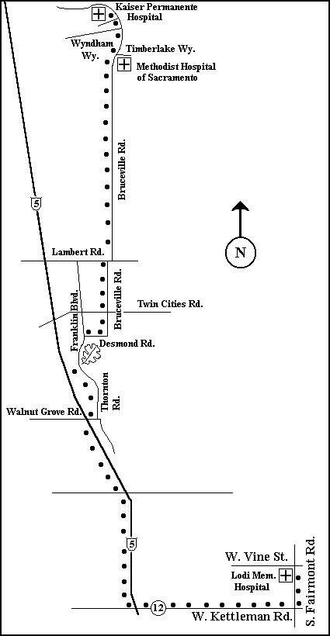
Figure 3: Hospital Directions

Appendix 2. Blank Maps/Sample Maps

Blank Maps/Sample Maps
Attach copies of the monitoring map(s) here.

Appendix 3. Herbicide Use Record Forms

When using herbicides it is critical (and, in many cases, required by law) to keep detailed records of all relevant information. Ideally, records would include data on the condition of the site prior to herbicide application, the type of species present, and percent cover of invasive and native species prior to application. This information will be valuable in evaluating the effectiveness of the herbicide. At the time of application, take detailed notes of the type and concentration of the herbicide, the amount, location, and method of application, weather conditions, and any other observations made during the course of application. This information is important in evaluating the project’s success, improving methodology, and identifying mistakes. In addition, it documents the procedure for future site managers and biologists. As in Appendix 2, you may use “TNC’s Policy, Procedures, and Guidelines for Use of Herbicides…”

Appendix 4. Herbicide Use Protocols

Herbicide Labels
Attach copies of the herbicide label(s) here.

