Weeds in the Wild: Weed Management in Natural Areas, version September 2001
- Instructions on use of the Pamphlet -

Assembly Instructions:
1)Print a master copy of the pamphlet using either a color or black & white printer.
2)Photocopy the two page pamphlet onto the back and front of a single 8.5 x 11 page.
3)Fold the page into thirds, as if you were mailing it in a standard envelope. Make the folds so the title page with the TNC logo is on top.

Tips:
1)If you can afford it, you may get the best results by having the printing and duplicating done at a local copy-services store.
2)This document uses the font “Baskerville Old Face”. If your machine does not support this, the pamphlet’s formatting may collapse (the pamphlet will no longer have the neat, two page/three column format). In this case, you can achieve a reasonably good-looking pamphlet by simply replacing the entire font selection with “Times New Roman”. Do not specify a font size when you do this--let the document’s own formatting make this choice. Additional fiddling may be required, but you know how computers are so I doubt this will be a surprise.

The WISP staff would like to thank Ross Geredien (bighorn sheep), USDA (asian longhorned beetle), Janet Haas (white ibis), Andrea Pickart (successful restoration) for the use of their images. The other images were provided by WISP staff Barry Meyers-Rice and John Randall.

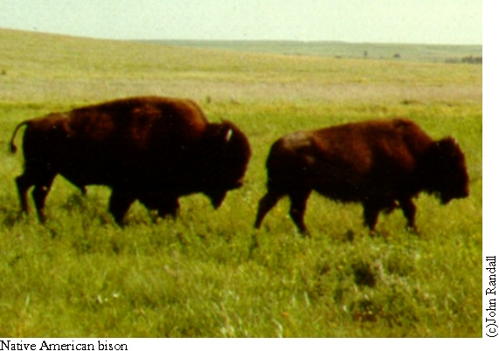
Mission Statement

“The mission of The Nature Conservancy is to preserve the plants, animals and natural communities that represent the diversity of life on Earth by protecting the lands and waters they need to survive.”

Invasive species can interfere with our mission by moving into natural landscapes and affecting native species, communities and systems. We work to promote flourishing native communities by preventing invasions and controlling invaders.
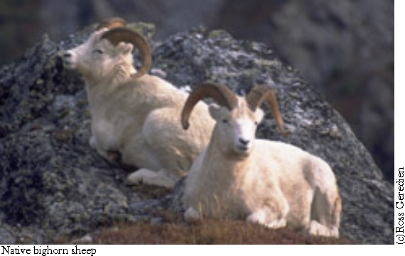
What is a non-native, invasive plant?
Most non-native plants introduced to new areas by humans do not cause environmental problems. Some, though, spread into wild habitats, reproduce, and become dominant, displacing native species and communities. The animals that depend upon the food and cover the native species provide suffer in turn. Invasive plants are truly a form of biological pollution!

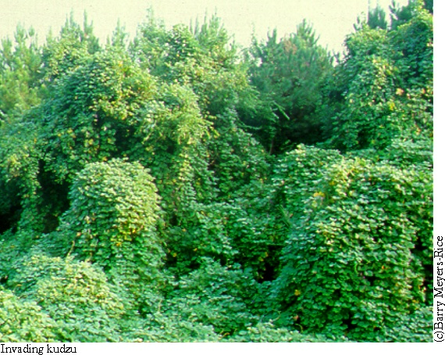

How do invasive plants affect the environment?
Invasive plants can displace or hybridize with native plants and some even change important natural processes. Some, like cheatgrass, change the frequency or severity of wildfires. Thirsty invaders, like tamarisk, use so much water that they lower the water table, even drying up water holes vital to scores of animals. Invasive plants can change the character of the landscape (for example, shrubs and trees invading a prairie grassland). They may even change the structure and chemical composition of the soil!
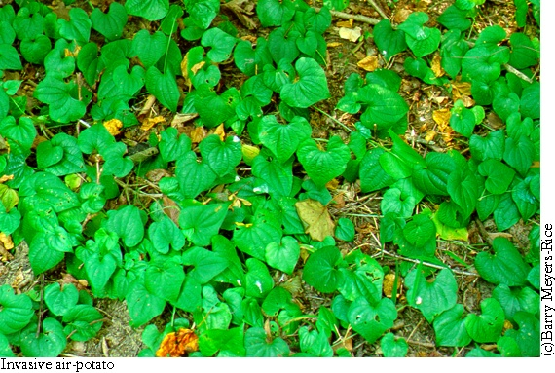
(c) Barry Meyers-Rice
Invasive species: not just plants
Not all invasive species are plants; natural areas are also degraded by invading animals. For example, a non-native insect, the woolly adelgid, is rapidly killing hemlock trees in the eastern USA. Non-native feral pigs in many parts of the world disturb native vegetation, kill ground-nesting birds, and root through the soil, leading to erosion and degraded water quality.
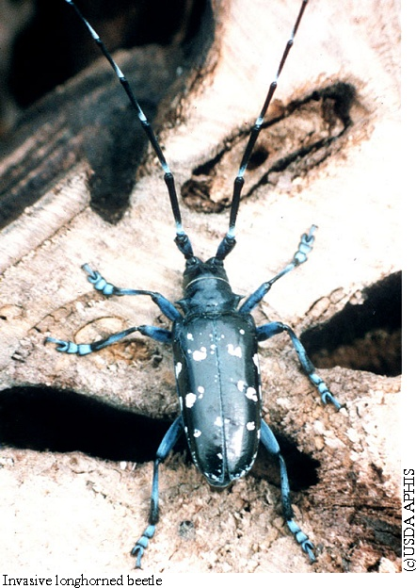

Managing for the environment
Invasive species management does not focus on controlling plants simply because they are not native. Instead, we control only organisms that have adverse effects on native biodiversity. Our native plants and animals need a place to live and thrive.
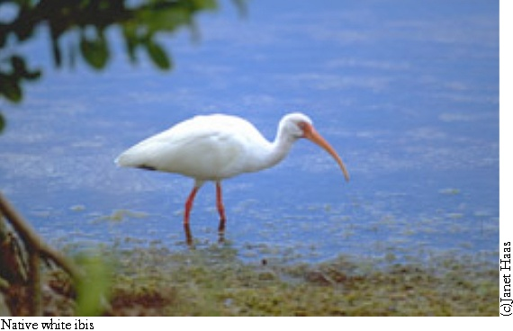
Success is achievable...
Successful control of invasive species can restore degraded, invaded habitats. For example, volunteers in Oregon removed invading diffuse knapweed from the wooded hillsides and open grassland slopes that provide habitat for over 300 plant species. Meanwhile, removal of alien beachgrass from Lanphere Dunes Preserve in California naturally restored native plant cover! Conservation takes time, effort, and good planning!
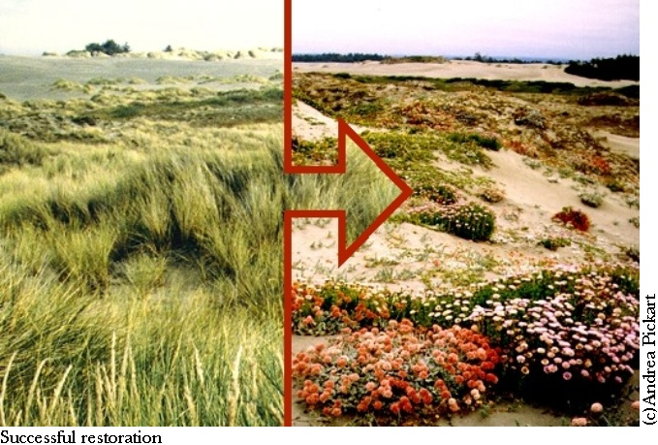
Restoring damaged ecosystems...
We use a variety of tools and techniques when controlling invasive species. Pulling, cutting, burning, applying herbicides, mowing, grazing, and using biological control agents are all tools in our big toolbox! We recognize that all tools have environmental effects and are careful to use only those that do more good than harm in each situation.

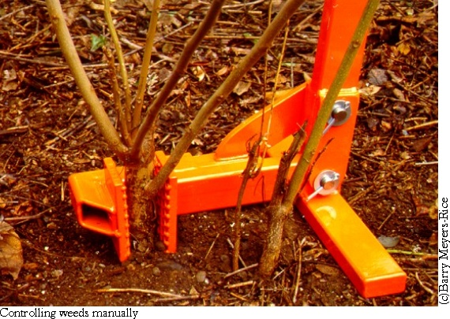

An ounce of prevention!
The most effective way to protect natural areas from invading species is prevention. Understanding what invasive species are and how they affect the environment is important for us all. When buying plants for your garden, avoid plants that are invasive. Contact your local nursery, agricultural extension agent, master gardener, native plant society, or our web site for more information. Be especially watchful for invasive species if you live near a natural area. Do not forget that wind, streams or even rainwater drainage systems can carry weed seeds far from your home, into wild habitats!

Weeds in the Wild

Weed Management in Natural Areas

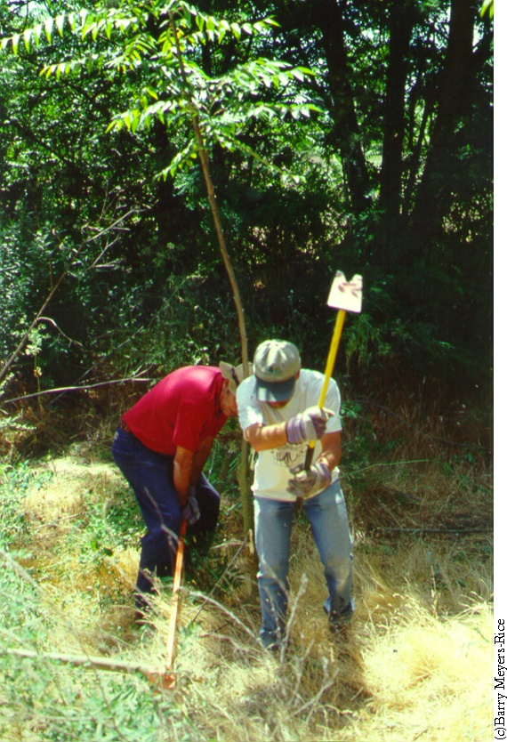

 http://tncweeds.ucdavis.edu 

(c)WISP/2001

