IMAZAPIC

Synopsis

Herbicide Basics

Chemical formula: (±)-2-[4,5-dihydro-4-methyl-4-(1-methylethyl)-5-oxo-1H-imidazol-2-yl]-5-methyl-3-pyridinecarboxylic acid

Herbicide Family: Imidazolinone

Target Species: selected annual and perennial broadleaves and grasses
Forms: acid, ammonium salt
Formulations: SL, DG
Mode of Action: Inhibits the enzyme acetohydroxyacid synthase (AHAS), that is involved in the synthesis of aliphatic amino acids
Water Solubility: 2200 mg/L at 25° C

Adsorption potential: low
Primary degradation mech: microbial activity
Average Soil Half-life: 120 days

Mobility Potential: low
Dermal LD50 for rabbits:
>5,000 mg/kg
Oral LD50 for rats:
>5,000 mg/kg
LC50 for bluegill sunfish:
>100 mg/L

Trade Names: Plateau®, Cadre®, Plateau Eco-Paks®
Manufacturer: BASF (previously American Cyanamid Company)

Imazapic is a selective herbicide for both the pre-and post-emergent control of some annual and perennial grasses and some broadleaf weeds. Imazapic kills plants by inhibiting the production of branched chain amino acids, which are necessary for protein synthesis and cell growth. It has been useful for weed control in natural areas, particularly in conjunction with the establishment of native warm-season prairie-grasses and certain legumes. Imazapic is relatively non-toxic to terrestrial and aquatic mammals, birds, and amphibians. Imazapic has an average half-life of 120 days in soil, is rapidly degraded by sunlight in aqueous solution, but is not registered for use in aquatic systems.

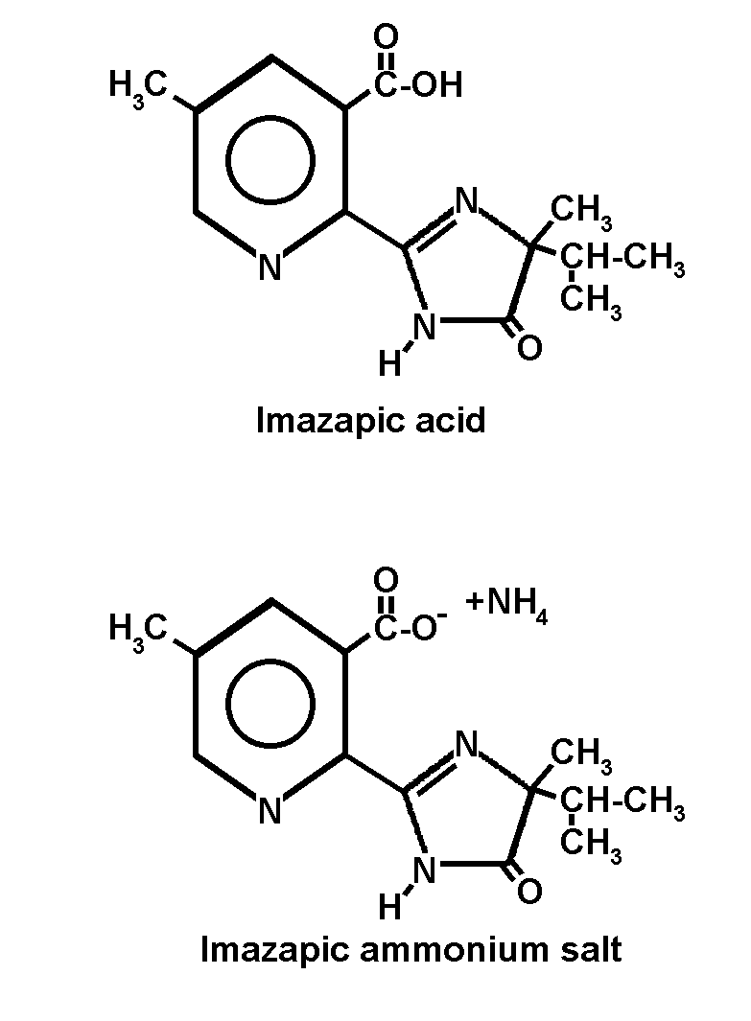
Herbicide Details

Chemical Formula: (±)-2-[4,5-dihydro-4-methyl-4-(1-methylethyl)-5-oxo-1H-imidazol-2-yl]-5-methyl-3-pyridinecarboxylic acid

Trade Names: Imazapic (formerly called imazameth or AC 263,222) is sold under the trade names Plateau® and Cadre®. Both brands are sold as soluble liquid (SL) or dispersible granule (DG) formulations, and are also sold in pre-measured Plateau® or Cadre Eco-Paks® (just mix into water). Cadre® is manufactured for application in peanut crops; Plateau® is registered for wildland, pasture, and rangeland use.

Manufacturer: Plateau® and Cadre® are exclusively manufactured by BASF (previously by American Cyanamid Company, which was purchased by BASF in 2000).

Use Against Natural Area Weeds: Imazapic selectively kills plants depending on the species and the rate of application. It can control some annual and perennial broadleaves and grasses, including cocklebur (Xanthium strumarium), buffalobur (Solanum rostratum), Johnsongrass (Sorghum halepense), cheatgrass or downy brome (Bromus tectorum), bermudagrass (Cynodon dactylon), bahiagrass (Paspalum nutatum), smartweed (Polygonum persicaria), and leafy spurge (Euphorbia esula). In some instances, non-native weeds are more susceptible than the desirable native species, and imazapic has been used in prairie renovation and restoration projects. Beran et al. (1999) demonstrated that by controlling invasive non-native weeds, imazapic helped encourage the growth of certain native legumes. Washburn et al. (1999, 2000) and Washburn & Barnes (2000) used imazapic to sharply reduce the exotic tall fescue (Festuca arundinacea) and allow native warm-season grasses to return to Kentucky grasslands. Native species productivity and diversity, especially bird diversity, was promoted when imazapic was applied pre- and post-emergence at 0.2 kg/ha.

Masters et al. (1998) reported that a single autumn application of imazapic at 140 g/ha effectively controlled leafy spurge (Euphorbia esula) in Nebraska. Further, imazapic promoted the establishment of native prairie wildflowers in areas with high weed interference (Beran et al. 1999). In Iowa, Joy Williams (IA Dept. of Transportation) reports that imazapic applied at 8 to 12 oz/ac with 2 oz/ac methylated seed soil suppressed non-native Kentucky bluegrass and tall fescue. The Iowa Dept. of Transportation is interseeding native grasses to enhance restoration.

Jeff Connor of Rocky Mountain National Park reported a short-term decrease in above-ground stem densities of leafy spurge (50 to 90% reductions) in areas treated with imazapic (applied 3 times at 4 to 8 oz/ac), but the roots were not impacted, even after 2 years of application. Thus, two years post-application, leafy spurge stem densities returned to nearly pre-treatment levels. Jeff recommends that imazapic be used with a biocontrol agent for good leafy spurge control (J. Connor, pers. comm.).

On TNC preserves, imazapic is being used for leafy spurge control at Big Bluestem Prairie in western Minnesota. Anton Benson and Pete Baumann report good control (over 90%) of leafy spurge by using imazapic. They initially used imazapic applied at 8oz/ac, but were concerned by some apparent stunting of some native wet prairie plant species the growing season post-application. They have since halved their application rate (to 0.5oz/gallon in a backpack solution), and have not noticed any stunting of the native vegetation. Anton adds that there is a relatively narrow application timeframe for good results. He recommends applying imazapic to leafy spurge during green-up following summer senescence, but a few weeks prior to killing frost. Leafy spurge can regenerate from seeds in the soil seedbank, so repeat applications will be necessary for long term control. Anton also adds that the use of imazapic can be used to facilitate the establishment of the biocontrol agents (Aphthona beetles) on leafy spurge.

Use Against Cropland and Rangeland Weeds: Imazapic has been used successfully to control cropland and rangeland weeds. In Australian rangelands, Melland & McLaren (1998) reported promising results using imazapic (applied at 0.048 kg ai/ha) to control serrated tussock (Nassella trichotoma). In croplands, Wilcut et al. (1999) reported that imazapic applied at 72 g ai/ha controlled Johnsongrass, crabgrass (Digitaria sanguinalis), redroot pigweed (Amaranthus retroflexus), sicklepod (Senna obtusifolia), and morningglory (Ipomoea spp) in corn (Zea mays) without any noticeable damage to the crop. Monks et al. (1998) also found that imazapic (at 0.064 lb ai/acre) controlled Johnsongrass in West Virginia. Abayo et al. (1998) mixed imazapic with imazapyr (45 g ae/ha + 27 g ae/ha) and successfully delayed witchweed (Striga spp.) emergence in corn.

Post-emergence application of imazapic (at 50 to 70 g ai/ha), combined with crop rotations of corn, peanut (Arachis hypogaea), and cotton (Gossypium hirsutum), resulted in the successful control of purple nutsedge (Cyperus rotundus) (Warren & Coble 1999). Imazapic has also been reported to control quackgrass (Elytrigia repens) and Canada thistle (Cirsium arvense) in corn (Sprague et al. 1999), red rice (Oryza sativa) and Echinochloa spp. in soybean (Glycine max) (Askew et al. 1998; Noldin et al. 1998), and Palmer amaranth (Amaranthus palmeri), eclipta (Eclipta prostrata), and pitted morningglory (Ipomoea lacunosa) in peanut (Grichar 1997a,b; Grey et al. 2000). Additionally, imazapic suppressed seedhead production in bahiagrass (Paspalum notatum) (Baker et al. 1999).

Mode of Action: Imazapic kills plants by inhibiting the activity of the enzyme acetohydroxy acid synthase (AHAS or ALS). ALS catalyzes the production of three branched-chain aliphatic amino acids, valine, leucine, and isoleucine, required for protein synthesis and cell growth. The rate of plant death is usually slow (several weeks), and is likely related to the amount of stored amino acids available to the plant. Only plants have ALS and produce these three amino acids, therefore, imazapic is of low toxicity to insects, fish, and other animals. Animals need these three branched chain aliphatic amino acids, but obtain them by eating plants or other animals.

Dissipation Mechanisms:

Summary: Imazapic is degraded primarily by soil microbial metabolism. The extent to which imazapic is degraded by sunlight is believed to be minimal when applied to terrestrial plants or soil, but it is rapidly degraded by sunlight in aqueous solutions. Imazapic is not degraded by other uncatalyzed chemical reactions in the environment. It is moderately persistent in soils, and has not been found to move laterally with surface water. Imazapic does not volatilize when applied in the field.

Volatilization
Imazapic is not volatile, and binds weakly to moderately with most soil types. Adsorption increases with decreasing soil pH and increasing clay and organic matter content (American Cyanamid 2000).

Photodegradation
Imazapic’s half-life on soils due to photolysis is 120 days. In aqueous solutions however, imazapic is rapidly broken down by photolysis with a half-life of just one or two days (American Cyanamid 2000).

Microbial Degradation
The primary mechanism of degradation is via microbial action. Imazapic’s half-life in soil ranges from 31 to 233 days depending upon soil characteristics and environmental conditions (American Cyanamid 2000).

Adsorption
Imazapic is weakly adsorbed in high pH soil. Adsorption increases as the pH decreases and with increasing clay and organic matter content. There is little lateral movement of imazapic in soil (American Cyanamid 2000).

Chemical Decomposition
Imazapic is not degraded by other abiotic chemical reactions in the environment (American Cyanamid 2000).

Behavior in the Environment
Summary: Imazapic is moderately persistent in soil, but has only limited mobility. It is soluble, but not degraded, in water. Imazapic is however, rapidly photodegraded by sunlight in aqueous solution. “Leakage” of imazapic from plant roots is unlikely.

Soil
Based on field dissipation studies, imazapic is moderately persistent in soils with a DT50 (time required for concentration in soil to reach 50% of initial measured concentration) of 7 to 150 days depending upon soil type and climatic conditions.

Imazapic has limited horizontal mobility in soil, and generally moves just 6 to 12 inches, although it can leach to depths of 18 inches in sandy soils (R. Lym, pers. comm.). Soil binding is a complex function of soil pH, texture, and organic matter content. Imazapic adsorption to soil may increase with time. Imazapic does not volatilize from the soil surface and photolytic breakdown on soils is negligible. The major route of imazapic loss from soil is through microbial degradation (WSSA 1994; American Cyanamid 2000).

Water
Imazapic is soluble in water and is not degraded hydrolytically in aqueous solution. Imazapic in water is, however, rapidly photodegraded by sunlight with a half-life of one to two days. Field studies do not indicate any potential for imazapic herbicide to move from soils with surface water (American Cyanamid 2000). Imazapic is not registered for aquatic use.

Vegetation
Imazapic is readily absorbed through leaves, stems, and roots, and is then translocated rapidly throughout the plant, and accumulates in the meristematic regions. “Leakage” of imazapic from the roots of a treated plant to other nearby plants is unlikely because imazapic has great difficulty crossing the Casparian strip in roots (J. Vollmer, pers. comm.). Treated plants stop growing soon afterwards. Chlorosis appears first in the newest leaves, and tissue death spreads from these points. In perennials, imazapic is translocated into, and kills, underground storage organs which prevents regrowth. Chlorosis and tissue necrosis may not be apparent in some plant species for several weeks after application. Complete kill of plants may not occur for weeks or even months after application (American Cyanamid 2000).

Environmental Toxicity
Birds and Mammals
Imazapic is of low toxicity to birds and mammals. According to the manufacturer, imazapic does not bioaccumulate in animals, as it is rapidly excreted in urine and feces. It is therefore, essentially non-toxic to a wide range of non-target organisms, including mammals, birds, fish, aquatic invertebrates, and insects. The oral LD 50 of imazapic is >5,000 mg/kg for rats and >2,150 mg/kg for bobwhite quail, indicating that imazapic is relatively non-toxic by ingestion in single doses. In the 2 ASU (2 lb. a.e./gal) liquid formulation, imazapic is nonirritating to skin and eyes in single doses. The acute dermal LD50 was > 5,000 mg/kg (body weight) for rabbits, and imazapic is not a skin sensitizer for guinea pigs. Even direct application of imazapic technical (100% active ingredient) causes only minimal, transient eye irritation, and complete recovery occurs within 72 hours. The inhalation toxicity of imazapic technical is also very low. Chronic consumption of imazapic technical in the diet of mice for 18 months, and by rats for 2 years elicited no adverse health effects at the highest doses tested. Chronic consumption by dogs in a one-year study caused minimal effects, which included a slight degeneration/necrosis of single muscle fibers and lymphocyte/macrophage infiltration in skeletal muscle in both males and females, and slightly decreased serum creatinine in females only. No clinical observations indicative of muscle dysfunction were noted in any animal in these studies, and microscopic analyses indicated that the impact to muscle cells, would not impair or adversely affect the functional capacity of the affected skeletal muscles (American Cyanamid 2000).

Aquatic Species
Imazapic itself is of moderate toxicity to fish. The LC50s for technical grade imazapic for both bluegill sunfish (Lepomis macrochirus) and rainbow trout (Oncorhynchus mykiss) are >100 mg/L. Water fleas (Daphnia magna) also had an LC50 of >100 mg/L. Imazapic, however, rapidly degrades in aqueous solution, rendering it relatively safe to aquatic animals (American Cyanamid 2000).

Other Non-Target Organisms
The LC50 for honey bees (Apis mellifera) is >100 mg/bee, indicating that imazapic is nontoxic to bees (American Cyanamid 2000).

Application Considerations:
Imazapic can be applied using conventional application methods (sprayers, controlled drop, injectors, wipe-on devices, etc.). The manufacturer suggests using either a broadcast sprayer or using a spot treatment, with a backpack or other ground equipment.

Post-emergent imazapic applications require the use of a spray adjuvant, such as methylated seed oil (MSO) or vegetable oil concentrate. Nonionic and silicone-based surfactants may also be used, but are generally less effective. Nitrogen-based liquid fertilizers may also be applied with imazapic, but may increase injury to desired species.

Imazapic may be mixed with other herbicides such as triclopyr (Garlon®), glyphosate (RoundUp®), picloram (Tordon®), imazapyr (Arsenal®), or other products to provide total vegetation control. Mixtures of imazapic with 2,4-D and other phenoxy-type herbicides, however, provided less control of perennial grass weeds than imazapic alone. Combining imazapic with other herbicides, according to the manufacturer, should not increase the toxicological risk over that of either herbicide when used alone.

Safety Measures: Provide adequate ventilation and wear a respirator, rubber gloves, goggles, and protective clothing when handling. Remove contaminated clothing and launder prior to reuse. Shower after completion of work shift. Wash hands with soap and water before eating, smoking, or using the toilet. Store in a secure, dry, well-ventilated, separate room, building or covered area.

Human Toxicology: Imazapic is not considered carcinogenic. The U.S. EPA has classified imazapic as a “Group E” compound, or one that has not shown evidence of carcinogencity in humans, based on studies with rats and mice (American Cyanamid 2000).

References
Abayo, G.O., English, T., Eplee, R.E., Kanampiu, F.K., Ransom, J.K. and J. Gressel. 1998. Control of parasitic witchweeds (Striga spp.) on corn (Zea mays) resistant to acetolactate synthase inhibitors. Weed Science 46: 459-466.
American Cyanamid Company. 2000. Plateau herbicide, for weed control, native grass establishment and turf growth suppression on roadsides and other noncrop areas., PE-47015. Parsippany, NJ.
Askew, S.D., Street, J.E. and D.R. Shaw. 1998. Herbicide programs for red rice (Oryza sativa) control in soybean (Glycine max). Weed Technology 12: 103-107.
Baker, R.D., McCarty, L.B., Colvin, D.L., Higgins, J.M., Weinbrecht, J.S. and J.E. Moreno. 1999. Bahiagrass (Paspalum notatum) seedhead suppression following consecutive yearly applications of plant growth retardants. Weed Technology 13: 378-384.
Beran, D.D., Gaussoin, R.E. and R.A. Masters. 1999. Native wildflower establishment with imidazolinone herbicides. HortScience 34(2): 283-286.
Beran, D.D., Masters, R.A. and R.E. Gaussoin. 1999. Grassland legume establishment with imazethapyr and imazapic. Agronomy Journal 91: 592-596.
Grey, T.L., Bridges, D.C. and B.J. Brecke. 2000. Response of seven peanut (Arachis hypogaea) cultivars to sulfentrazone. Weed Technology 14: 51-56.
Grichar, W.J. 1997a. Control of Palmer amaranth (Amaranthus palmeri) in peanut (Arachis hypogaea) with postemergence herbicides. Weed Technology 11: 739-743.
Grichar, W.J. 1997b. Influence of herbicides and timing of application on broadleaf weed control in peanut (Arachis hypogaea). Weed Technology 11: 708-713.
Masters, R.A., Beran, D.D. and F. Rivas-Pantoja. 1998. Leafy spurge (Euphorbia esula) response to AC 263,222. Weed Technology 12: 602-609.
Melland, A. and D. McLaren. 1998. Efficacy of herbicides against serrated tussock (Nassella trichotoma) in a pot trial. Plant Protection Quarterly 13(2): 102.
Monks, C.D., Vencill, W.K., Hatton, J.P., McFarland, M.L. and D.P. Delaney. 1998. Johnsongrass response to postemergence herbicides applied the previous year. Journal of Production Agriculture 11(4): 507-509.
Noldin, J.A., Chandler, J.M., McCauley, G.N. and J.W. Sij, Jr. 1998. Red rice (Oryza sativa) and Echinochloa spp. control in Texas Gulf coast soybean (Glycine max). Weed Technology 12: 677-683.
Sprague, C.L., Frasier, A.L. and D. Penner. 1999. Identifying acetolactate synthase inhibitors for potential control of quackgrass (Elytrigia repens) and Canada thistle (Cirsium arvense) in corn (Zea mays). Weed Technology 13: 54-58.
Warren, L.S., Jr. and H.D. Coble. 1999. Managing purple nutsedge (Cyperus rotundus) populations utilizing herbicide strategies and crop rotation sequences. Weed Technology 13: 494-503.
Washburn, B.E. and T.G. Barnes. 2000. Postemergence tall fescue (Festuca arundinacea) control at different growth stages with glyphosate and AC 263,222. Weed Technology 14: 223-230.
Washburn, B.E., Barnes, T.G. and J.D. Sole. 1999. No-till establishment of native warm-season grasses in tall fescue fields. Ecological Restoration 17(3): 144-149.
Washburn, B.E., Barnes, T.G. and J.D. Sole. 2000. Improving northern bobwhite habitat by converting tall fescue fields to native warm-season grasses. Wildlife Society Bulletin 28(1): 97-104.
Wilcut, J.W., Richburg, J.S. III and F.R. Walls, Jr. 1999. Response of Johnsongrass (Sorghum halepense) and imidazolinone-resistant corn (Zea mays) to AC 263,222. Weed Technology 13: 484-488.
WSSA. 1994. AC 263,222. In: Herbicide Handbook, 7th Edition. Weed Science Society of America, Champaign, Illinois. 352 pp.

Date Authored: April 2001
Updated: January 2004

