FLUAZIFOP-P-BUTYL

Synopsis
Fluazifop-p-butyl kills annual and perennial grasses, but does little or no harm to broad-leaved plants (dicots). It kills by inhibiting lipid synthesis (lipids are necessary components of cell membranes), particularly at the sites of active growth. In the environment, fluazifop-p-butyl is degraded primarily through microbial metabolism and hydrolysis. It is not degraded readily by sunlight. The half-life of fluazifop-p-butyl in soils is one to two weeks. Because it binds strongly with soils, fluazifop-p-butyl it is not highly mobile and is not likely to contaminate ground water or surface water through surface or sub-surface runoff. In water, fluazifop-p-butyl is rapidly hydrolyzed to fluazifop acid, which is stable in water. Fluazifop-p-butyl is of relatively low toxicity to birds and mammals, but can be highly toxic to fish and aquatic invertebrates.

Herbicide Basics

Chemical formula: R-2-[4-[[5-(trifluoromethyl)-2-pyridinyl]oxy]phenoxy] propanate

Herbicide Family: Aryloxyphenoxy-propionate
Target Species: annual and perennial grasses
Forms: butyl ester
Formulations: EC
Mode of Action: Lipid synthesis inhibitor
Water Solubility: 1.1 ppm
Adsorption potential: high
Primary degradation mech: microbial metabolism and hydrolysis
Average Soil Half-life:
15 days
Mobility Potential: low
Dermal LD50 for rabbits:
>2,420 mg/kg
Oral LD50 for rats:
4,096 mg/kg
LC50 for bluegill sunfish:
0.53 mg/L
Trade Names: Fusilade®, Horizon 2000®, Ornamec®, Fusion®, Tornado®
Manufacturers:
AgrEvo, PBI/Gordon, and Zeneca

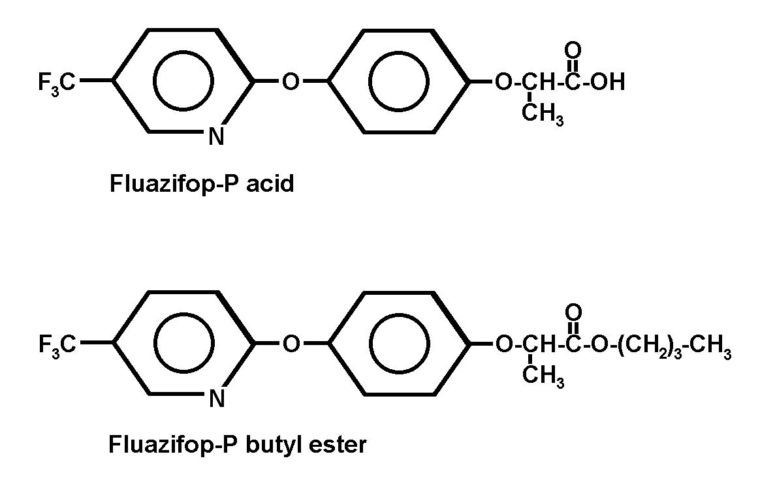
Herbicide Details

Chemical Formula: R-2-[4-[[5-(trifluoromethyl)-2-pyridinyl]oxy]phenoxy] propanate

NOTE: The fluazifop-butyl molecule can take two forms, the R- and S-isomers, but only the R-isomer is herbicidally active. A few years ago, formulations of fluazifop-butyl were changed so that they contain only the herbicidally active form (R-isomer), fluazifop-p-butyl. Some of the studies reported in this chapter were conducted using the mixed formulation of fluazifop-butyl, which contained both R- and S- isomers. There is some evidence that the two isomers behave differently in the environment. New formulations that contain only the R-isomer form may not behave in the environment as some older studies have predicted.

Trade Names: Fusilade 2000®, Fusilade DX®, Fusilade Turf and Ornamental®, Fusilade Fiv®, Fusilade Supe®r, Fusion®, Horizon®, Ornamec®, and Tornado®

Manufacturer: Zeneca Agricultural Products, AgrEvo, PBI/Gordon

Use Against Natural Area Weeds: Both annual and perennial grasses can be controlled by fluazifop-p-butyl, including bromes (Bromus spp.), quackgrass (Elytrigia repens), johnsongrass (Sorghum halepense), and panic or witch-grasses (Panicum spp.).

Fluazifop-p-butyl has not been used extensively on TNC preserves, but small-scale trials have generated some promising results. In Ohio, smooth brome (Bromus inermis) was signficantly weakened but not killed following applications of fluazifop-p-butyl. In Oregon on the Ewauna Flats Preserve, trials were conducted against quackgrass (Elytrigia repens var. repens) using glyphosate, sethoxydim, and fluazifop. Fluazifop had the greatest impact on the weed. After one application, stem density had not changed but quackgrass cover was reduced and the native plant targeted for conservation (Astragalus applegatei) increased in density. Darren Borgias and Molly Sullivan (TNC-SW Oregon) report that fluazifop must be applied repeatedly (late May, early July) to actively growing plants (> 6 in) for good control of quackgrass. A combination of burning followed by fluazifop also significantly lowered aboveground cover of quackgrass, but only by about 8%. They used a foliar spray at 0.125 kg/ai/ha of fluazifop with 0.25% Triton, a non-ionic surfactant. They hope that an intensive regime using controlled burns and multiple applications of fluazifop will provide complete control of quackgrass. Recent studies in California have also demonstrated effective control of jubatagrass (Cortaderia jubata) with fall applications of fluazifop-p-butyl (DiTomaso, pers. comm.; Drewitz 2000).

Mode of Action: Fluazifop-p-butyl is a post-emergence phenoxy herbicide. It is absorbed rapidly through leaf surfaces and quickly hydrolyzes to fluazifop acid. The acid is transported primarily in the phloem and accumulates in the meristems where it disrupts the synthesis of lipids in susceptible species (Urano 1982; Erlingson 1988). Fluazifop-p-butyl inhibits acetyl CoA carboxylase, an enzyme that catalyzes an early step in fatty acid synthesis. Lipids are important components of cellular membranes, and when they cannot be produced in sufficient quatities, cell membrane integrity fails, especially in regions of active growth such as meristems. The cells then burst, or leak and die. Fluazifop-p-butyl affects susceptible grasses, but does not affect most other monocots or dicots.

Dissipation Mechanisms:
Summary: Fluazifop-p-butyl is degraded primarily by hydrolysis, and secondarily by microbial metabolism. It is not degraded by photolysis or other chemical means. It can bind strongly with soil particles and is not water-soluble. Fluazifop-p-butyl does not volatilize readily.

Volatilization
Fluazifop-p-butyl is non-volatile in the field (T. Lanini, pers. obs.). The potential to volatilize, however, may increase with increasing temperature, increasing soil moisture, and decreasing clay and organic matter content (Helling et al. 1971).

Photodegradation
The WSSA Herbicide Handbook (1994) reports negligible loss from photodegradation in laboratory studies. It is relatively stable to breakdown by UV or sunlight (EXTOXNET 1996). No published studies regarding photodegradation of fluazifop-p-butyl were found.

Microbial Degradation
Degradation of fluazifop-p-butyl in the environment can occur by either hydrolysis or by microbial degradation. Soils with conditions that favor microbial metabolism (i.e. warm and moist) will have the highest rates of degradation (Negre et al. 1993). Fluazifop’s average field half-life is 15 days (WSSA 1994). Metabolism by soil microbes first converts the herbicide to its acid form (fluazifop acid), which is further degraded by microbes, and can have a half-life of less than 1 week (EXTOXNET 1996).

Adsorption
Fluazifop-p-butyl binds strongly with soils. Gessa et al. (1987) found that fluazifop-p-butyl can form irreversible bonds with certain clay soils by several different mechanisms. Despite its strong adsorption to soils, Kulshrestha et al. (1995) found that fluazifop-p-butyl leached to at least 15 cm deep in soybean fields in India. Fluazifop-p-butyl is reported to be of low mobility in soils and does not present an appreciable risk of groundwater contamination (EXTOXNET 1996; WSSA 1994).

Chemical Decomposition
Fluazifop-p-butyl readily degrades through hydrolysis to fluazifop acid in soils and water. Increased temperatures can increase the rate of hydrolysis (Balinova & Lalova 1992). No other mechanism of chemical degradation has been reported.

Behavior in the Environment
Summary: Fluazifop-p-butyl is rapidly hydrolyzed to fluazifop acid in vegetation, soils, and water. In plants, fluazifop acid is herbicidally active. In soils and water, both the ester and acid forms are metabolized by soil or sediment microbes, and broken-down to herbicidally inactive compounds. The average soil half-life of the ester form is one to two weeks. Fluazifop-p-butyl binds readily with soil particles, limiting leaching and soil runoff.

Soils
Fluazifop-p-butyl is rapidly hydrolyzed by microbes to fluazifop acid in soils (Smith 1987). The average half-life of fluazifop-p-butyl is one to two weeks (WSSA 1994). Conditions that promote microbial activity in soils, such as high moisture levels, favor degradation (Negre et al. 1988; Somich et al. 1988; Negre et al. 1993). Smith (1987) reported that in moist soils, only 8% of the fluazifop-butyl remained in the soil after 48 hours, whereas in dry soils, over 90% of the ester remained after 48 hours. One study showed that the S-isomer, which is no longer used in brand-name Fusilade® formulations, is more readily metabolized by microbes than the R-isomer (Negre et al. 1993). Complete degradation of formulations sold today (composed primarily of the R-isomer), therefore, may take longer than the S- and R-isomer fluazifop-butyl mixture.

Water
Fluazifop-p-butyl is not water-soluble. Because it binds strongly with soils, it is not highly mobile in soils and does not pose a significant risk of groundwater contamination (WSSA 1994). In water, fluazifop-p-butyl rapidly hydrolyzes to fluazifop acid, with the rate of hydrolysis increasing with increasing pH (Negre et al. 1988). Fluazifop acid is stable in water at all pHs tested.

Vegetation
Fluazifop-p-butyl is completely metabolized within the plant to fluazifop acid two to four weeks following application (Balinova & Lalova 1992; Kulshresha et al. 1995). The acid takes longer to degrade, with residues remaining in the plant up to 45 days after treatment (Balinova & Lalova 1992).

Environmental Toxicity
Birds and Mammals
Studies have shown fluazifop-p-butyl to be “slightly to practically nontoxic” to mammals and birds that ingest it and only “slightly” toxic to animal skin and eyes (EXTOXNET 1996). Oral LD50 levels of fluazifop-p-butyl were > 4,000 mg/kg for male rats, >3,500 mg/kg for mallard ducks, and >4,659 mg/kg for bobwhite quail.

Aquatic Species
Fluazifop-p-butyl can pass readily into fish tissue, and is highly toxic to fish and other aquatic species, including invertebrates (Daphnia 48 hr LC50 > 10 mg/L). Studies have shown “very high to high” toxicity in bluegill sunfish (96 hr LC50 = 0.53 mg/L) and rainbow trout (96 hr LC50 = 1.37 mg/L) (EXTOXNET 1996). Fluazifop-p-butyl is not registered for use in aquatic systems.

Other Non-Target Organisms
Fluazifop-p-butyl has been shown to inhibit fungal growth (Abdel-Mallek et al. 1996; Gorlach-Lira et al. 1997). Abdel-Mallek et al. (1996) found that fungal populations were temporarily (one to two weeks) decreased at rates above 3.0 ug/g and for longer periods of time (more than eight weeks) at rates above 6.0 ug/g. Fluazifop does not have a significant effect on fungal populations when applied at recommended field rates.

Application Considerations:
Fluazifop-p-butyl is ineffective under drought conditions. Growth regulating herbicides are only effective when plants are growing. Under drought conditions, no new plant growth occurs, and the herbicide is rendered ineffective. Some herbicides remain in the plant until new growth resumes, but fluazifop-p-butyl is metabolized rapidly by the plant and, consequently, is no longer present when growth resumes weeks or months later.

Synergistic Effects:
Synergism may occur when two or more herbicides are mixed and applied together and the impact of the mixture is greater than when the herbicides are applied separately. The effectiveness of the herbicide mixture, therefore, may be multiplied by using a lesser amount of total herbicide than if applied separately. Synergistic effects have the benefits of saving money (amount spent on herbicides) and reduce the total amount of herbicide applied, thereby minimizing potential for environmental contamination. A drawback of using more than one herbicide, however, is that adequate research (by the manufacturer and others) has not been conducted on the overall impacts and toxicity of mixtures of this sort.

Synergistic effects of fluazifop-p-butyl mixed with several herbicides have been noted. Harker and O’Sullivan (1991) found that a mixture of fluazifop-p-butyl and sethoxydim provided more control over grass species than the two herbicides applied separately. Additionally, because each herbicide provided better control over different set of grass species, the effects of mixing the herbicides were complimentary as well as synergistic. For example, fluazifop provided better control of wheat and barley, while sethoxydim provided better control of green foxtail (Harker & O’Sullivan 1991).

Antagonistic Effects
Antagonistic effects have been reported between fluazifop-p-butyl and auxin mimic herbicides such as 2,4-D. When applied together, the auxin mimic effectively controls broadleaf plants but the normal control of grasses provided by fluazifop-p-butyl is lost.

Safety Measures:
Fluazifop-p-butyl is irritating to skin, can cause eye damage, and is harmful if inhaled. Care should be taken to prevent accidental splashing or other exposure to the herbicide.

Human Toxicology:
Fluazifop-p-butyl is of relatively low toxicity to mammals, but can be an irritant (eye, skin, respiratory passages, and skin sensitizer), and is toxic if inhaled.

References
Abdel-Mallek, A. Y., M. I. A. Abdel-Kader, and S. A. Omar. 1996. Effect of the herbicide fluazifop-butyl on fungal populations and activity in soil. Water Air Soil Pollut. 86:151-157.
Balinova, A. M., and M. P. Lalova. 1992. Translocation, metabolism and residues of fluazifop-butyl in soybean plants. Weed Res. 32:143-147.
Drewitz, J.J. 2000. Reproductive biology and control of jubatagrass (Cortaderia jubata). Master’s Thesis, University of California, Davis.
Erlingson, M. 1988. Fusilade - a strategy for long-term control of couch (Elymus repens). Weeds and Weed Control. 1:158-165.
EXTOXNET. 1996. Fluazifop-p-butyl. Pesticide Information Profiles. Extension Toxicology Network. http://ace.orst.edu/info/extoxnet/.
Gessa, C., A. Pusino, V. Solinas, and S. Petretoo. 1987. Interaction of fluazifop-butyl with homoionic clays. Soil Sci. 144:420-424.
Gorlach-Lira, K., O. Stefaniak, W. Slizak, and I. Owedyk. 1997. The response of forest soil microflora to the herbicide formulations Fusilade and Roundup. Microbiol. Res. 152:319-329.
Helling, C. S., P. C. Kearney, and M. Alexander. 1971. Behavior of pesticides in soil. Adv. Agron. 23:147-240.
Negre, M., M. Gennari, V. Andreoni, R. Ambrosoli, and L. Celi. 1993. Microbial metabolism of fluazifop-butyl. J. Environ. Sci. Health B28(5):545-576.
Negre, M., M. Gennari, A. Cignetti, and E. Zanini. 1988. Degradation of fluazifop-butyl in soil and aqueous systems. J. Agric. Food Chem. 36:1319-1322.
Smith, A. E. 1987. Persistence studies with the herbicide fluazifop-butyl in Saskatchewan soils under laboratory and field conditions. Bull. Environ. Contam. Toxicol. 39:150-155.
Urano, K. 1982. Onecide, a new herbicide fluazifop-butyl. Jap. Pestic. Inf. 41:28-31.
WSSA. 1994. Herbicide handbook. Weed Society of America. Champaign, Illinois. 352 pp.

Date Authored: April 2001

