M. Tu, C. Hurd, R. Robison & J.M. Randall

CLOPYRALID

Synopsis
Clopyralid is an auxin-mimic type herbicide. It is more selective (kills a more limited range of plants) than some other auxin-mimic herbicides like picloram, triclopyr, or 2,4-D. Like other auxin-mimics, it has little effect on grasses and other monocots, but also does little harm to members of the mustard family (Brassicaceae) and several other groups of broad-leaved plants. Clopyralid controls many annual and perennial broadleaf weeds, particularly of the Asteraceae (sunflower family), Fabaceae (legume family), Solanaceae (nightshade family), Polygonaceae (knotweed family), and Violaceae (violet family). It is chemically similar to picloram, but clopyralid has a shorter half-life, is more water-soluble, and has a lower adsorption capacity than picloram. Clopyralid’s half-life in the environment averages one to two months and ranges up to one year. It is degraded almost entirely by microbial metabolism in soils and aquatic sediments. Clopyralid is not degraded by sunlight or hydrolysis. The inability of clopyralid to bind with soils and its persistence implies that clopyralid has the potential to be highly mobile and a contamination threat to water resources and non-target plant species, although no extensive offsite movement has been documented. Clopyralid can cause severe eye damage if splashed into the eyes during application, but otherwise is non-toxic to fish, birds, mammals, and other animals.

Herbicide Basics

Chemical formula: 3,6-dichloro-pyridinecarboxylic acid

Herbicide Family:
Pyridine (Picolinic Acid)
Target weeds: annual and perennial broadleaf weeds, esp. knapweeds, thistles, and other members of the sunflower, legume, and knotweed families
Forms: salt & ester
Formulations: SL, WG
Mode of Action: Auxin mimic
Water Solubility: 1,000 ppm
Adsorption potential: low
Primary degradation mech: Slow microbial metabolism
Average Soil Half-life: 40 days
Mobility Potential: high
Dermal LD50 for rabbits:
>2,000 mg/kg
Oral LD50 for rats:
4,300 mg/kg
LC50 for bluegill sunfish:
125 mg/L
Trade Names: Transline®, Stinger®, Reclaim®, Curtail®, and Lontrel®
Manufacturers:
DowAgroSciences (formerly known as DowElanco)

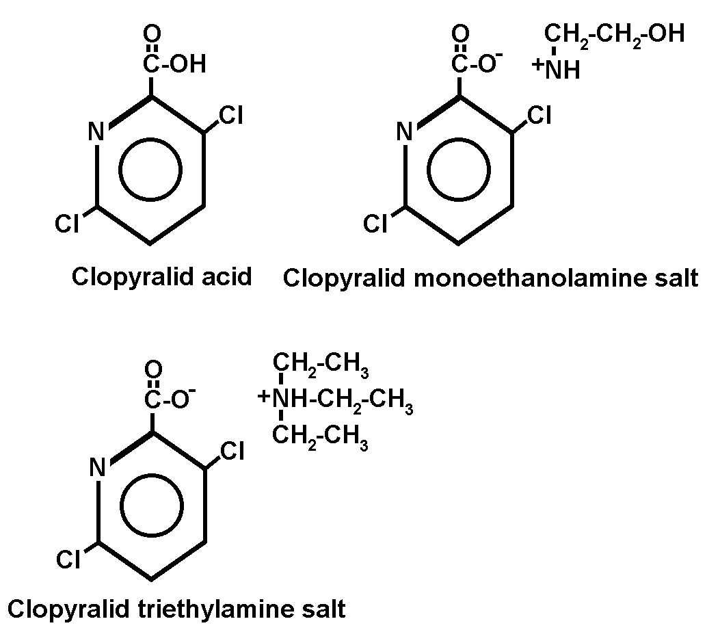
Herbicide Details:

Chemical Formula: 3,6-dichloro-2-pyridinecarboxylic acid

Trade Names: Clopyralid is sold as an acid, ester, or salt under the trade names Transline®, Stinger®, Reclaim®, and Curtail®. Formulations labelled for non-cropland use include Transline® (clopyralid amine salt formulation) and Curtail® (clopyralid amine salt plus 2,4-D amine salt formulation).

Manufacturer: DowAgrosciences (formerly known as DowElanco)

Use Against Natural Area Weeds: Clopyralid is an auxin-mimic herbicide like picloram, triclopyr, or 2,4-D, but it is more selective than these compounds. Like other auxin-mimics, it has little effect on grasses and other monocots but also does little harm to members of the mustard family (Brassicaceae) and several other groups of broad-leaf plants. Clopyralid controls many annual and perennial broadleaf weeds, particularly of the Asteraceae (sunflower family), Fabaceae (legume family), Solanaceae (nightshade family), Polygonaceae (knotweed family), and Violaceae (violet family). The basis of this selectivity is not well understood.

On TNC preserves, clopyralid has been used against Canada thistle (Cirsium arvense), honey mesquite (Prosopis glandulosa), Russian knapweed (Acroptilon repens), yellow starthistle (Centaurea solstitialis), Chinese privet (Ligustrum sinense), bird’s-foot trefoil (Lotus corniculatus), English ivy (Hedera helix), and Chinese wisteria (Wisteria sinensis). A mixture of clopyralid and 2,4-D (Curtail®) was used to control Canada thistle at the Silver Creek Preserve (Idaho) in 1991. In some cases, Canada thistle may remain dormant or inconspicuous for a season after being treated with these herbicides, but may recover two growing seasons after treatment. A follow-up treatment may be necessary.

DiTomaso et al. (1999) found clopyralid provided effective pre- and post-emergent control of yellow starthistle at very low application rates (e.g. 1 oz a.e./acre) in tests conducted at several sites in California. Season-long control was achieved with applications made in December or later. Earlier applications resulted in higher forage production than did later treatments (DiTomaso et al. 1999).

Mode of Action: Clopyralid is an “auxin mimic” or synthetic auxin. This type of herbicide kills the target weed by mimicking the plant growth hormone auxin (indole acetic acid), and when administered at effective doses, cause uncontrolled and disorganized plant growth that leads to plant death. The exact mode of action of clopyralid has not been fully described but it is believed to acidify the cell wall, which results in cell elongation. Low concentrations of clopyralid can stimulate RNA, DNA, and protein synthesis leading to uncontrolled cell division and disorganized growth, and ultimately, vascular tissue destruction. High concentrations of clopyralid can inhibit cell division and growth.

Degradation and Immobilization Mechanisms:
Summary: In soil and water, clopyralid is degraded primarily by microbial metabolism. It is resistant to degradation by sunlight, hydrolysis, or other chemical degradation. It is water-soluble, does not bind strongly with soils, and has the potential to be highly mobile in soils, especially sandy soils. Clopyralid is not highly volatile.

Volatilization
Clopyralid does not volatilize readily in the field (T. Lanini, pers. obs.). The potential to volatilize, however, increases with increasing temperature, increasing soil moisture, and decreasing clay and organic matter content (Helling et al. 1971).

Photodegradation
Clopyralid is not degraded significantly by sunlight (WSSA 1994; DowElanco 1997).

Microbial Degradation
Clopyralid is degraded primarily by microbes in soils and aquatic sediments (Pik et al. 1977). Rates of microbial metabolism increase with increasing soil moisture and temperature, and decrease with increasing amounts of organic matter. No metabolites accumulate during the degradation process, therefore, no additional contamination of the environment occurs (Pik et al. 1977).

Adsorption
Clopyralid is water-soluble and does not bind strongly to soils (Cox et al. 1996). During the first few months following application, clopyralid has a strong potential for leaching and possibly contaminating groundwater supplies. Adsorption has been shown to increase with time (Pik et al. 1977; DowElanco 1997), which can limit long term leaching. Pik et al. (1977) estimated that clopyralid was a class 5 (very mobile) herbicide using the Helling et al. (1971) scheme.

Chemical Decomposition
Clopyralid is not susceptible to hydrolysis or other types of chemical degradation (DowElanco 1977; Bergstrom et al. 1991).

Behavior in the Environment
Summary: Clopyralid is relatively persistent in soil, water, and vegetation. It is degraded almost entirely by soil microbes and is not susceptible to photo or chemical degradation. Once clopyralid is applied to soils, it rapidly disassociates (Shang and Arshad 1998), becoming extremely soluble in water, and does not bind strongly with soil particles. Lack of adsorption means that clopyralid has the potential to be mobile and could contaminate ground and surface water via leaching and surface and sub-surface water flows. However, no case of extensive off-site movement has been documented (J. DiTomaso, pers. comm.).

Soils
Clopyralid is moderately persistent in soils. Because it is degraded entirely by soil microbes, soil conditions that maximize microbial activity (warm and moist) will facilitate clopyralid degradation (Pik et al. 1977; DowElanco 1997). The average half-life of clopyralid in soils is one to two months but can range from one week to one year depending on the soil type, temperature, and rates of application (Pik et al. 1977; Smith and Aubin 1989; Bergstrom et al. 1991; Bovey and Richardson 1991; DowElanco 1997). Warm, moist soils treated at low rates will lose clopyralid in a comparatively short period, whereas when applied to cold, dry soils, or waterlogged soils, and at higher rates, clopyralid residues may persist for several years (Pik et al. 1977). Although some soils lose clopyralid quickly (3-4 weeks, Galoux et al. 1985), it generally takes a year or more for clopyralid to decrease to undetectable levels in treated soils (Pik et al. 1977; Smith and Aubin 1989).

When clopyralid enters the soil through direct spray, runoff from plant foliage, or translocation from the roots of treated plants, it rapidly disassociates to the anion form. The negatively charged anion form is highly water-soluble and has a very low capacity to adsorb to soil particles. Consequently, clopyralid has the potential to be highly mobile in the environment. Elliott et al. (1998) found clopyralid leached to depths as great as 180 cm within 20 days of application. Clopyralid’s chemical characteristics suggest it has a high potential for movement, but most field studies found that it is not as mobile expected (Pik et al. 1977; Bergstrom et al. 1991; Bovey and Richardson 1991, DowElanco 1997). Where clopyralid leaches to lower soil depths, it persists longer than it does at the surface because the microbial populations generally decrease with soil depth (Pik et al. 1977).

Aquatic
Clopyralid is highly water-soluble and will not bind with suspended particles in the water column. Degradation is almost entirely through microbial metabolism in aquatic sediments, but because clopyralid does not bind with sediments readily, it can be persistent in an aquatic environment. The half-life of clopyralid in water ranges from 8 to 40 days (DowElanco 1977). Following aerial application to soils at the rate of 2.5 kg formulated product/ha (more than two times the label rate for non-cropland use in California), Leitch and Fagg (1985) recorded peak concentrations of 0.017 mg/L in a nearby stream that drained the area. They estimated that a total of 12 g of clopyralid (0.01% of that applied) leached into the stream during the first significant rainfall after the application that occurred three days later. Bergstrom et al. (1991) found a maximum of 0.02% of applied clopyralid was lost to runoff from clay soils in Sweden. Clopyralid is not registered for use in aquatic systems.

Vegetation
Clopyralid passes rapidly into leaves and roots of plants and is rain-fast within two hours (Devine et al. 1990; Kloppenburg and Hall 1990). Once inside the plant, clopyralid is converted to the anion form and transported throughout the plant. It is not readily degraded by the plant and can be persistent, even in non-susceptible species (DowElanco 1997).

Environmental Toxicity
Birds and Mammals
Clopyralid is practically non-toxic to birds and mammals. The LD50 for rats is 4,300 mg/kg. For mallards and bobwhite quail, the LD50s are 1,465 mg/kg and >4,640 mg/kg, respectively. The manufacturer reports that studies found that the majority of clopyralid ingested by mammals was excreted unmetabolized in their urine within 24 hours (DowElanco 1997). Some clopyralid, however, was retained in their livers and kidneys. Because clopyralid is not degraded rapidly in treated plants, wildlife could ingest clopyralid when feeding on treated browse. In a study of the effects of clopyralid on bobwhite quail egg hatchability and chick immunocompetence, Dabbert et al. (1997) concluded that clopyralid did not cause significant effects to bobwhite quail embryos.

Aquatic Species
Clopyralid is of low toxicity to aquatic animals (DowElanco 1997). Its LC50s for bluegill sunfish and rainbow trout are 125 mg/L and 104 mg/L, respectively.

Other Non-Target Organisms
Clopyralid is of very low toxicity to most animals including soil invertebrates and microbes (DowElanco 1997).

Application Considerations:
Foliar application of clopyralid may provide more complete control than soil application (DowElanco 1997). In the case of Canada thistle, foliar application results in the death of both the roots and top-growth, while soil application will damage only the roots and may not kill the plants. Direct soil application, however, may prevent germinating seedlings from emerging (DowElanco 1997).

Safety Measures:
Clopyralid can cause severe eye damage. Care should be taken to prevent clopyralid from splashing or otherwise getting into anyone’s eyes.

Human Toxicology:
Clopyralid is of relatively low toxicity to mammals but can cause severe eye damage including permenant loss of vision.

References
Bergstrom, L. 1991. Leaching potential and decomposition of clopyralid in Swedish soils under
field conditions. Environ. Toxicol. Chem.
Bovey, R. W., and C. W. Richardson. 1991. Dissipation of clopyralid and picloram in soil and seep flow in the Blacklands of Texas. J. Environ. Qual. 20:528-531.
Dabbert, C. B., R. B. Mitchell, and D. T. Oberheu. 1997. Northern bobwhite egg hatchability and chick immunocompetence following a field application of clopyralid. Bull. Environ. Contam. Toxicol. 58(5):801-806.
DiTomaso, J. M., G. B. Kyser, S. B. Orloff, S. F. Enloe, and G. A. Nader. 1999. New growth regulator herbicide provides excellent control of yellow starthistle. Calif. Agricult. 53(2):12-16.
DowElanco. 1997. Clopyralid, a North American technical profile. Indianapolis, IN.
Elliott, J.A., A.J. Cessna, K.B. Best, W. Nicholaichuk, and L.C. Tollefson. 1998. Leaching and preferential flow of clopyralid under irrigation: Field observations and simulation modeling. Journal of Environmental Quality 27: 124-131.
Galoux, M. P., A. C. Bernes, J-C. Van Damme. 1985. Gas chromatograhic determination of 3,6-dichloropicolinic acid residues in soils and its application to the residue dissipation in a soil. J. Agric. Food Chem. 33:965-968.
Helling, C. S., P. C. Kearney, and M. Alexander. 1971. Behavior of pesticides in soil. Adv. Agron. 23:147-240.
Kloppenburg, D. J., and J. C. Hall. 1990. Penetration of clopyralid and related weak acid herbicides into and through isolated cuticular membranes of Euonymus fortunei. Weed Res. 30:431-438.
Leitch, C., and P. Fagg. 1985. Clopyralid herbicide residues in streamwater after aerial spraying of a Pinus radiata plantation. N.Z J. For. Sci. 15(2):195-206.
Pik, A. J., E. Peake, M. T. Strosher, and G. W. Hodgson. 1977. Fate of 3,6-dichloropicolinic acid soils. J. Agric. Food Chem. 25(5):1054-1061.
Schutz, S., B. Weibbecker, and H. E. Hummel. 1996. Gas chromotography-mass spectrometry analysis of the herbicide clopyralid in differentially cultivated soils.
Shang, C., and M. A. Arshad. 1998. Sorption of clopyralid, dicamba and MCPA by two soils with conventional and no-till management. Can. J. Soil Sci. 78:181-186.
Smith, A. E., and A. J. Aubin. 1989. Persistence studies with the herbicide clopyralid in prairie soils at different temperatures. Bull. Environ. Contam. Toxicol. 42:670-675.
WSSA. 1994. Herbicide handbook. Weed Society of America. Champaign, Illinois. 352 pp.

Date Authored: April 2001

