WIMS Training Session – Preparation Notes

Dear WIMS Training Participant,

Hello! Thank you for your interest in WIMS (TNC’s Weeds Information Management System)! This WIMS training session is a one-day session that will begin at 9 am and should end by about 3pm. If you are interested in attending this session, please:

1. Download and print-out the WIMS support documentation,
2. Decide which hardware options you want, and purchase and bring handheld units (if you decide to use these) to the training,
3. Request an ArcPad 7.1 license from your state GIS/TIS person, and
4. Install the WIMS desktop (and handheld) components prior to the training.

These items are all detailed below. If you need additional assistance with installation, please plan on showing-up a little bit early to the training or do not hesitate to contact me.
Thanks! Mandy (imtu@tnc.org or 503-802-8150)

General Information - What is WIMS?
TNC’s Weeds Information Management System (WIMS) is a Microsoft Access database application that works to keep track of weed locations, size and status of weed patches and all management treatments. It can be used by itself on a desktop/laptop computer (the software is a free download), or you can use WIMS with an optional handheld computer for weed mapping and keeping track of treatments in the field. For more info on WIMS, see the webpages here http://tncweeds.ucdavis.edu/wims.html

# 1. Download and print-out the WIMS support documentation
All of the WIMS support documentation can be downloaded here http://tncweeds.ucdavis.edu/products/wims/documentation.html

For the training session, you should download (perhaps into a ‘WIMS Documentation’ folder) the following documents, and print-out and bring to the workshop the following:
a. WIMS 3 Installation Guide & Checklist (no need to print, unless you want)
b. Using WIMS 3 – A Tutorial Guide (please print a hardcopy and bring to training)
c. WIMS 3 User’s Manual (no need to print, unless you want)

If you will be using a handheld computer with WIMS, also print and bring the following two documents to the training:
d. Quicksteps to Using WIMS 3 in ArcPad 7.1
e. WIMS 3 Desk Handout

# 2. Decide which hardware options you want, and purchase and bring handheld units (if you decide to use these) to the training
WIMS is designed to be a stand-alone application in Access, or it can be used with a handheld computer to facilitate weed mapping in the field. If you decide that you want a handheld unit, see http://tncweeds.ucdavis.edu/products/wims/equipment.html for equipment options and please order asap to get the equipment in time for our training. There are lots of handheld equipment options – two of the most popular options right now are either the new HP iPAQ 210 (or 211) or the Trimble Juno ST. If you decide to go with the HP, you will also need a GPS unit (we have had good success with GlobalSat GPS units that use a Compact Flash connection). The HP iPAQ 210 retails for $450 and the Juno for $650. See below for more details on these two options.

# 3. Request an ArcPad 7.1 license from your state GIS/TIS person
On the handheld computer, WIMS uses the software ArcPad from ESRI. TNC has an agreement with ESRI where you can get an ArcPad license for free, but you have to ask your state GIS person to get a license for you (from the WO). Currently, most folks are using WIMS with either ArcPad 6.0.3, 7.0.1 or 7.1. For the training, I think we will be using ArcPad 7.1. Also on this page http://tncweeds.ucdavis.edu/products/wims/equipment.html is information on how to request an ArcPad license.

# 4. Install the WIMS desktop (and handheld) components prior to the training
It would be really great if everything is installed and set-up before the training so that we can avoid delays due to 'technical difficulties.' If you have any questions or run into any problems with installation, please contact me (imtu@tnc.org or 503-802-8100).

Follow the directions in the “WIMS 3 Installation Guide” for how to download and unzip the files and to set-up your new WIMS Access database on your laptop computer. Good luck, and let me know if you have any problems!

_____________________________________________________________

A Few Additional Items to Please Check, prior to the training session:

Is MS ActiveSync correctly installed?
If you will be using WIMS with a Handheld Computer (PDA), be sure MS ActiveSync is installed on the laptop you are bringing to the training (this should be included with your handheld purchase). It is correctly installed if you can connect the cradle for the PDA to the laptop and the ActiveSync window opens. You will also see the green ActiveSync icon in lower right of your screen (it will be grey if there is no active connection to the PDA). Or you can check Start > All Programs > Connections.


Older versions of MS ActiveSync
In order to use ArcPad 7 you must have ActiveSync 4.5 installed. If you have an old version of ActiveSync (from an older handheld), you can download the latest version of ActiveSync 4.5 here https://www.microsoft.com/windowsmobile/downloads/eula_activesync45_1033.mspx?ProductID=76
You can install this without uninstalling the old version. Note that any partnerships you have for your PDA will be deleted during the installation, so you will need to recreate them.

Check handheld set-up options
Open ArcPad on the PDA, select Tools on the top menu () and scroll to the Paths Tab. Make sure the Default Map and Data path is set to SD Card\WIMS. If it isn't, select the folder next to the field and browse to the WIMS folder. Then verify that the System Path is Program Files\ArcPad\System, or browse to that folder if the field is blank or points to another location. Finally, make sure the Applets path is BLANK, i.e., you don't want a value in this field. Providing a path for Applets makes the WIMS Toolbar appear twice on the screen. So select any value in this field and delete it.

Exit ArcPad and then open it again.

Next, select GPS Preferences (drop-down arrow next to GPS Position Window icon on the top menu and then GPS Preferences). Scroll over to the Datum tab and verify that the Datum is D_WGS_1984. If it is, OK out of the window and exit ArcPad. If the field is blank, select the drop-down arrow to see if you can select it. If there are no values available for selection and the field is blank, contact me as soon as possible via e-mail.

Review of hardware options by Nathan Rudd (TNC-Oregon office), May 2008
Below is a list my current ‘recommendations’, though I haven’t had the time or opportunity to rigorously test any of these. This list is based more on favorable reviews I’ve found on the web or what I’ve heard from users.

Non-rugged
HP iPAQs
I recommend the new 210 (or 211) Enterprise (see also http://www.brighthand.com/default.asp?newsID=13810) over the older hx2495. This retails for $450 (compared to ~$400 for the hx2495). It has a larger screen than the hx2495 (4" vs. 3.5"), a larger standard battery (should probably omit the need for an extended or extra battery, although these are available), a faster processor (624 vs. 520 MHz), and more RAM (128 vs. 64 MB). Also, it has a VGA screen, which should be more viewable outdoors (e.g. the Axim X51V had a VGA screen, which was brighter than that on the X51).

Trimble Juno
The Trimble Juno ST is a very small (see picture below), non-rugged PPC with an integrated, WAAS capable GPS unit. It’s only 2.4 x 4.3 x 0.7 inches (the screen is 2.8”, quite a bit smaller than either of the iPAQs). The Juno retails for $650. I’ve tested the GPS, which seems to work quite well. I was able to receive a WAAS signal in Portland (a ‘DGPS 3D Fix’ in ArcPad, which means locations should be within 2-5 m 95% of the time) – I don’t recall being able to do this with the GlobalSat BC-337 (which is also WAAS capable). The unit comes with a car charger and extra batteries are available for ~$40.

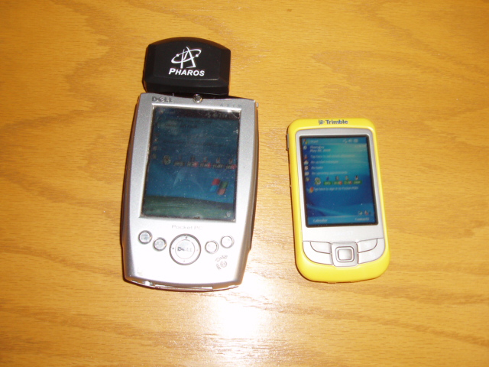
Figure 1. Dell Axim X5 (left) & Trimble Juno (right)

For non-rugged PPC, I recommend getting at least an AquaPac (the Large PDA Case for $40) and perhaps also a rugged case (e.g., the Otterbox 1900 for $99 - a GPS Pod is required for iPAQs with a CF GPS card, $35).

Rugged (mostly waterproof, dustproof and perhaps also ‘drop-proof’)
A few of the many available rugged PPC models are listed below.

Trimble Recon or Nomad
The Trimble Recon ($1495.00) and Nomad (~$1900) are both rugged units that come with a GPS (on the Recon, the GPS is either a CF Card or a Bluetooth, only the latter is WAAS capable). The Nomad comes with a faster CPU (800 vs. 400 MHz) and a lot more storage space (1 GB vs. 256 MB) and an integrated WAAS GPS unit. See a comparison of these models here. The GeoExplorer models are higher end units that range from $2600-$5300.

Roper Mobile Microflex 2240X
The Roper Microflex 2240X is slightly less expensive than the Trimble units (~$1365 with a GPS purchased separately through Semson’s, e.g., a GlobalSat BC-337). This price includes an upgrade to the 400 MHz processor (standard is 200 MHz) and an extended cap for a GPS unit. The GPS is cheaper through Semson’s than from the Roper vendor ($65 vs. $100-$200).

