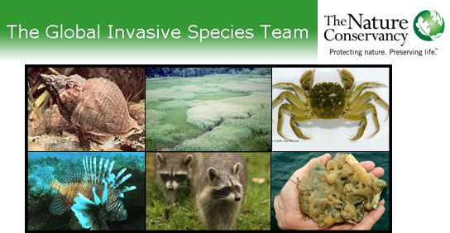

Eastern North America Invasive Species Learning Network presents
A Workshop on Invasive Species Prevention and Management:
Spotlight on Salty Species
October 7-9th, 2008
Silver Beach YMCA Conference Center, Eastern Shore, Virginia
http://www.campsilverbeach.org/

Dear Colleagues,

We are pleased to extend this invitation to you to join fellow ecologists, land stewards and government relations specialists from the Eastern and Southern U.S. Conservation Regions to Virginia's beautiful Eastern Shore to share challenges and innovations in preventing, managing and monitoring invasive species with a special emphasis in coastal and estuarine environments.

The projects that we will go deep into during this workshop highlight invasive species in wet habitats, but all the overall strategies, actions, measures and discussion topics will be applicable to all TNC staff who work on invasive species prevention and management.
In this workshop, we hope to accomplish the following objectives:

o Gain a collective understanding of the state of knowledge regarding coastal and estuarine invaders and the key strategies being implemented to combat them.
o Determine key government relations strategies for preventing coastal and estuarine invaders and how best to advance these within respective chapters as well as state and regional invasive species councils.
o Identify best practices in preventing and managing coastal and estuarine invaders in the context of sea level rise and global climate change.
o Conduct peer review and critique of measuring success of invasive species control and management projects in coastal environments.

Workshop details, including travel and registration information are now available at
http://tncweeds.ucdavis.edu/networks.html Hope to see you there!

Warm regards, The EIN 2008 Planning Team

